POST BOX- 306, KANNAVARITHOTA 4th LANE

GUNTUR (A.P) - INDIA – 522004
Email- Santhavardhan@yahoo.com www.goodnewsmessengers.org

Phone – 011-91-863-2354536

News Letter
March & April - 2007

Dr.M.S.Santhavardhan
DIRECTOR

Dear ones in Christ,

Greetings in Jesus precious name. By God’s grace we had a wonderful 3 day gospel campaign at KADAPA city. In this letter a few details are given.

This month many Christians are going to celebrate the events of GOOD FRIDAY & EASTER .

So let us briefly analyze the importance of these events concerning these festivals.

JESUS CHRIST ON THE CROSS
&
THE 7 WORDS HE UTTERED FROM THE CROSS

“For the message of the cross is foolishness to those who are perishing, but to us who are being saved it is the power of God.” - 1 Corinthians 1: 18

7 - WORDS OF JESUS ON THE CROSS

- First Word ( Luke 23:24 ) – Universal general amnesty proclaimed. Forgiveness proclaimed for the entire humanity.
- Second Word ( Luke 23 : 43 ) – Pray to Jesus and seek salvation like the thief on the cross then Lord at once gives us the assurance of the salvation. As the Lord has forgiven us we have to forgive our enemies.
- Third Word ( John 19 : 26 – 27 ) Jesus is not only concerned about our soul, but HE is also takes care of our physical needs. ( 1 Timothy 5 : 8 )
- Fourth Word ( Mathew 27 : 46 ) Lord Jesus is not suffering on the cross dubiously in a mystical body. He has partaken the human body of blood and flesh and suffering. HIS suffering is real.
- Fifth Word ( John 19 : 30 ) He is physically as well as spiritually also thirsty for the fellowship of the father and for the perishing souls. He also can quench our spiritual thirst. ( John 4 : 7 – 14 )
- Sixth Word ( John 19 : 30 ) Lord has victoriously finished the task given to Him to provide salvation for the entire world. Nothing to be added to it. Just your faith in HIM and in HIS redeemed work gives you salvation.
- Seventh W ord ( Luke 23 : 46 ) The Lord has committed HIS soul to the heavenly father.
How about your soul after your physical death?
To whom your soul would be given control of?
Where would you spend your eternity ? Hell or Heaven? (Luke 12: 19, 20) (Acts 7: 59)
(Luke 16 : 19 – 25 )

EASTER

According to Dr. Harvey M . Lifsey the following are some of the definite evidences for the resurrection of Jesus Christ.

- The empty tomb
- Rolled away stone.
- Shape of the grave clothes.
- The total inability of the Roman government to prove that Jesus was not alive.
- Physical appearances of Jesus Christ to many after His resurrection.
- A revolutionary transformation of the disciples of Jesus Christ who were once filled with great fear and timidity.
- The out pouring of the Holy Spirit.
- Rapid growth of Christianity.
- Even today in the name of Jesus souls are saved and people are delivered from the clutches of devil.
- Fulfillment of the Bible scriptures even in the ongoing world history.
Please see and meditate the following verses.
1 Corinthians 1: 23; Acts 2: 24; Revelations 1: 17 & 18

GOD’S OUTPOURING OF HIS HOLY SPIRIT ON THE
3 DAYGOSPEL CAMPAIGN AT KADAPA CITY
2nd,3rd & 4th March 2007

The El-Shaddai church members have fasted and prayed for 40 nights for a great revival in Kadapa city and gave publicity in around Kadapa city all through the district vigorously. We could see the results of prayers and their efforts.

Dr. Santhavardhan gave the 3 main messages in the evening public meetings and also gave sermons in the Sunday services of the 2 big local churches. He also participated in the morning meeting preached specially unto the hundreds of young girls and boys who were going to write their public examinations in the same week. Apart from Dr. Santhavardhan his wife and also his daughter Mrs. Merlyn Slivinsky ministered in the All Churches Women’s Fellowship on Sunday afternoon.

Mr. Shalem Vikranth vardhan was the chief co-ordinator and organizer who conducted this huge gospel campaign (Shali) while Jacob Jayanth vardhan was the Music director under whose music direction the famous movie singer, cine music director and celebrity Sreelekha and other singers moved the entire gathering by singing the devotional songs in a very sweet manner and under the special unction of the Lord.
The chief technical director of the Good News Messengers ministries Mr.Vijay Kumar (vijji), played a wonderful role behind the screed not only for the success of the campaign but also in guiding the TV crew.

All through 3 days inspite of the on going examinations for the students thousands of people thronged the mission grounds and heard the gospel messages given by Dr. Santhavardhan with rapt attention. Nearly 90% of the crowd responded to the alter call. Thus thousands of souls were saved. They have very seriously considered the word of God and dedicated their lives to the Lord. The Lord has performed several healing miracles also.

A thorn which was in the leg nerve of a young man for the past 6 years who was unable to walk was touched and healed by the Lord miraculously. When Dr. Santha vardhan has offered the mass healing prayer even from the stage the thorn has come out automatically from the leg nerve of the young man in a miraculous way. Immediately he was able to walk.

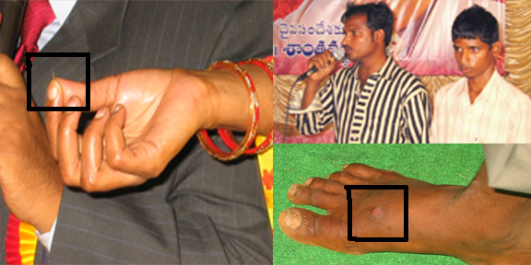

A Hindu Brahmin lady Lakshmi also testified to the gathering that her migraine head-ache which has tormented her for a period of 25 years just disappeared when she came and touched the garment of Dr. Santhavardhan in faith in the Kadapa meetings. As a result the entire Hindu family accepted Jesus and are baptized and participating in the ministry. Her son is dedicated to become a Christian evangelist instead of becoming a Hindu priest as originally planned.

On the last day when Dr. Santha vardhan has prayed, mighty anointing of the Lord has come upon the gathering and many people were weeping and wailing confessing their sins to the Lord. Several people were delivered from demon possession.

The mayor of the city and other big leaders and officials attended the meeting and testified that these meetings brought a real revival and blessing to the citizens of Kadapa city. On request, Dr. Santhavardhan has offered special prayers for the Chief Minister of Andhra Pradesh Dr. Rajasekhar Reddy, who hails from the same district.

Our orphan children known as Kids of Christ from the Guntur House of Hope orphanage have given very nice dance performances for the devotional songs and won the laurels of the crowd. All glory to our Lord and saviour Jesus Christ.

Apart from Kadapa meetings we had wonderful ministry in Hyderabad, Kodada, Vijayawada, Kothapalem, Mallepadu and other places . The son-in-law of
Dr. Santhavardhan who came from U.S.A Mr. Christopher Slivinsky also participated in the ministry during the month of February – March 2007.

Pictorial Report

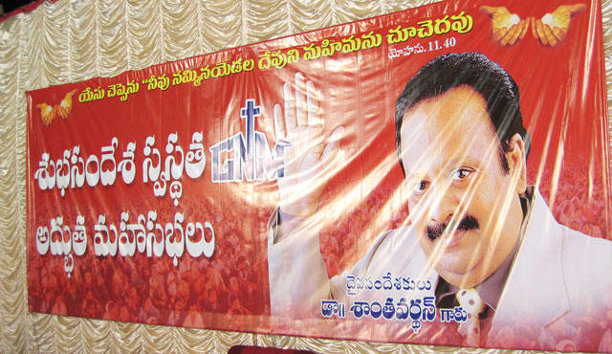

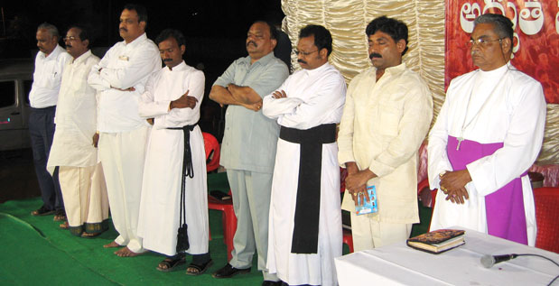
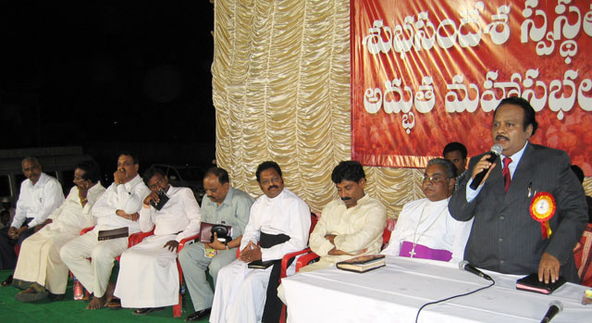

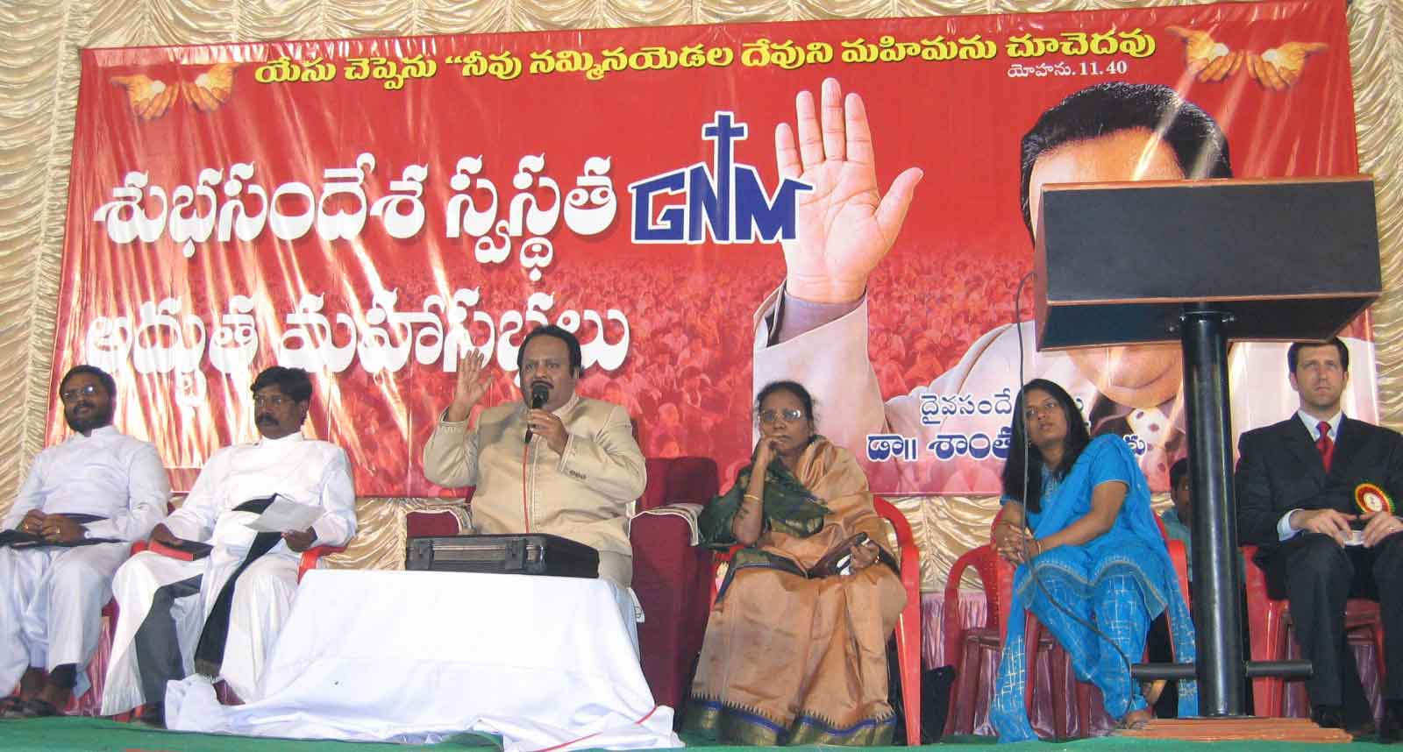

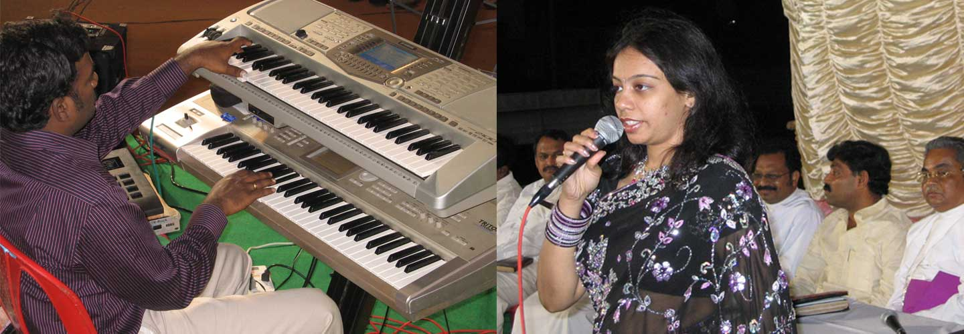

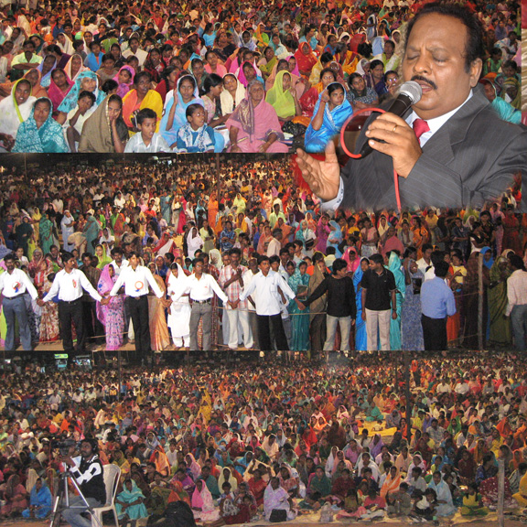

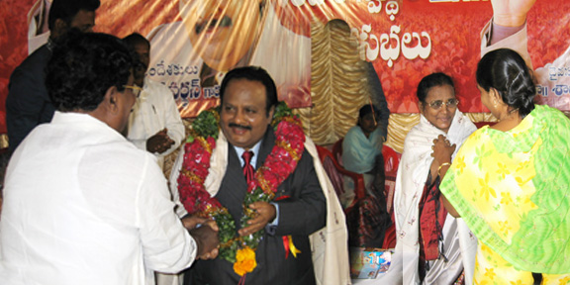

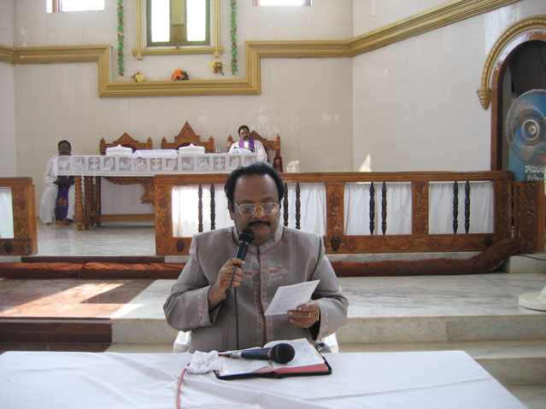

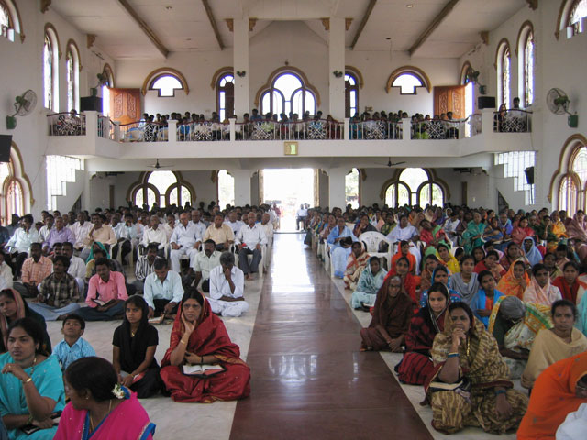

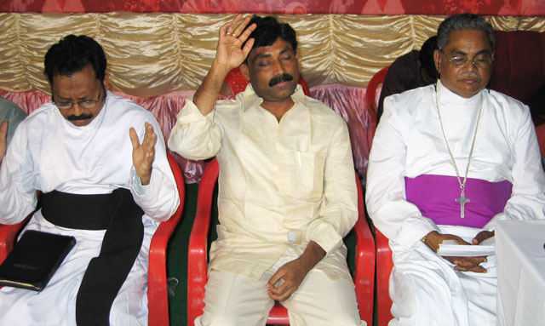
Mayor of the city Sri.Ravindranath Reddy responding to the alter call

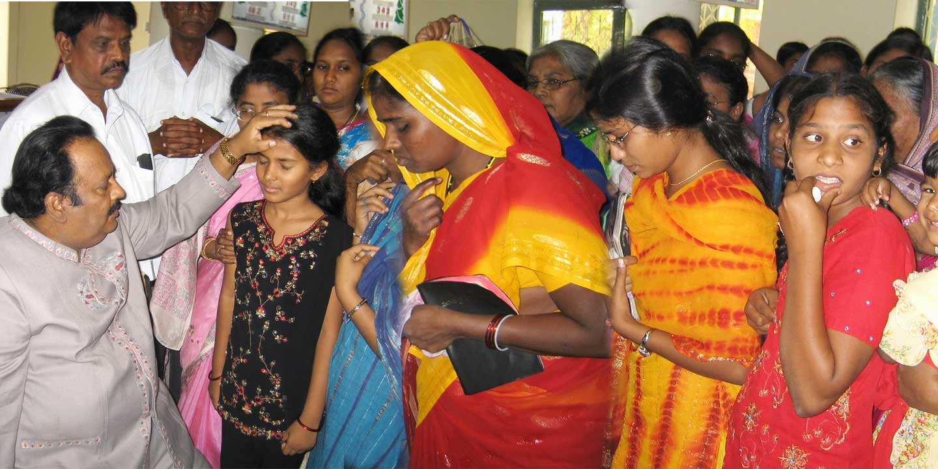
Special Personal Prayers

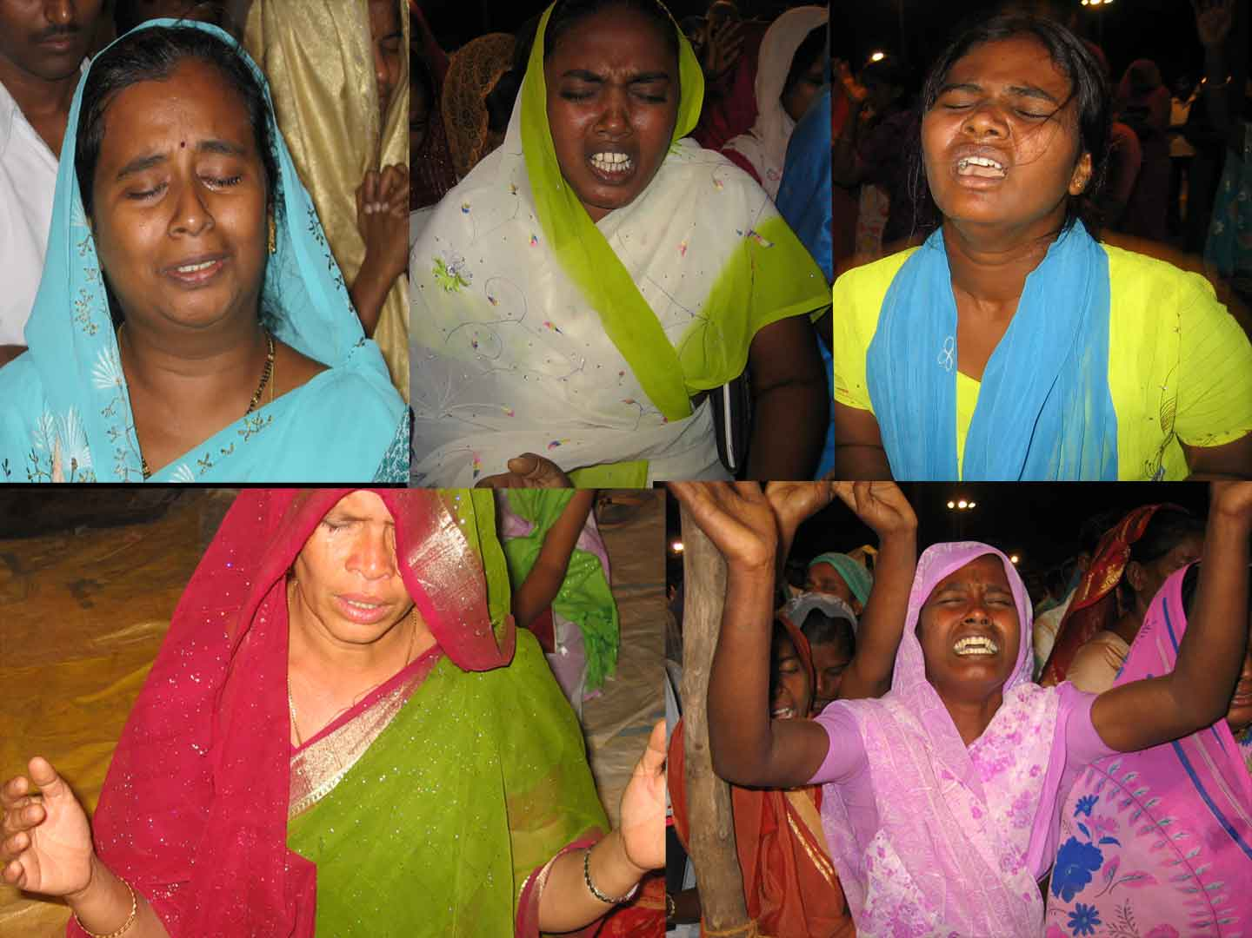
Minisrty with Christopher Slevenski(chris) Son-In-Law Of Dr.Santhavardhan
Out Pouring Of The HOLY SPIRIT On The Crowd

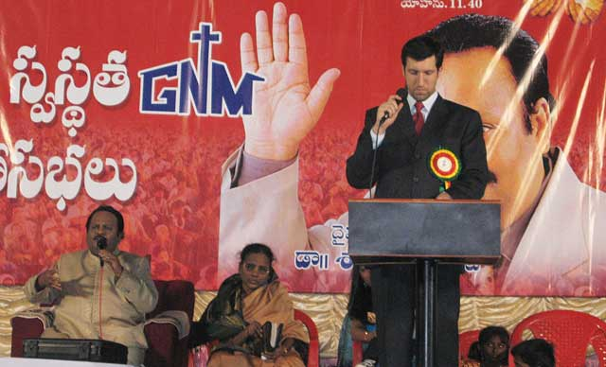

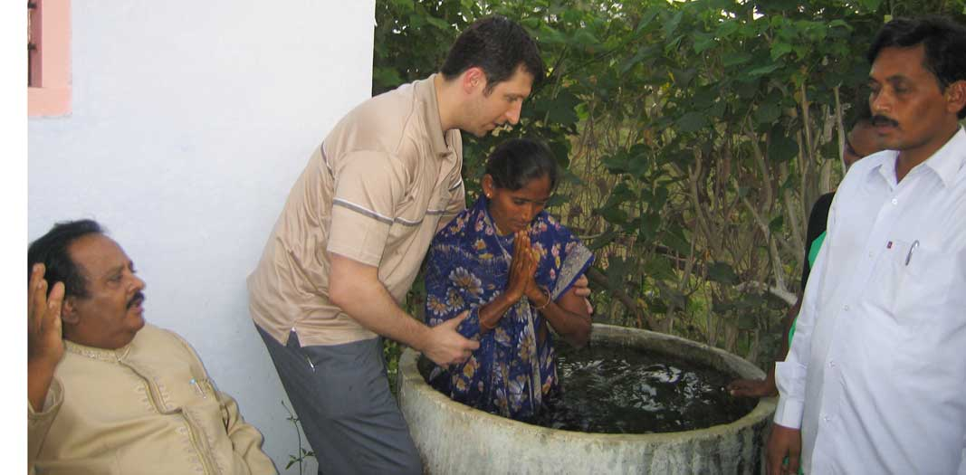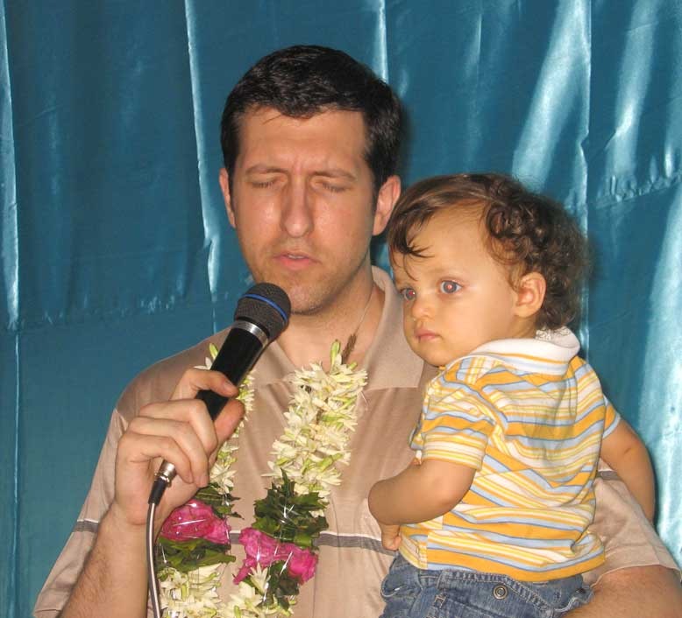

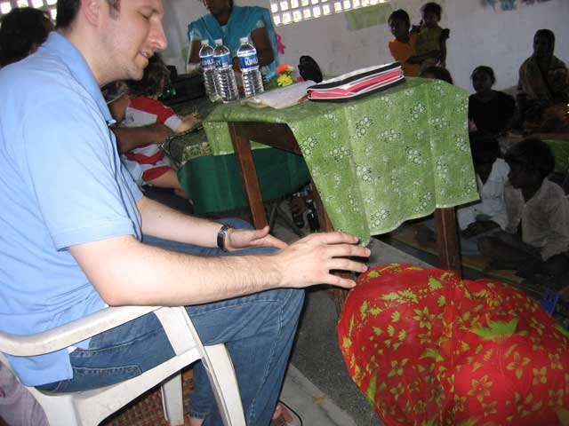

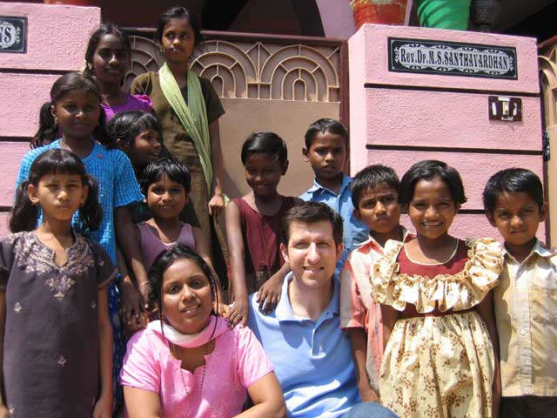

YOUR HELP

YOU CAN SEND YOUR CHEQUES IN THE NAME OF ‘GOOD NEWS MESSENGERS’ AND MAIL THEM DIRECTLY TO THE FOLLOWING ADDRESS BY REGISTERED MAIL.

REV.DR.M.S.SANTHA VARDHAN
DIRECTOR,
GOOD NEWS MESSENGERS
‘EL-SHADDAI’ CHURCH
KANNAVARITHOTA 4TH LANE
GUNTUR-522004.
SOUTH INDIA

TELEPHONE: 011-91-863-2354536.
CELL PHONE: 9848113886.

YOU CAN DIRECTLY SEND THE MONEY BY MAIL TRANSFER TO OUR BANK ACCOUNT IN INDIA.

SWIFT CODE: SBI NIN BB 181
ACCOUNT NO: 10949477027

DONORS IN USA
to get the tax deductible receipts may send their cheques in the name of
CALVARY LIFE FELLOWSHIP.
(for Good News Messengers in India)
to the following address:
CALVARY LIFE FELLOWSHIP,
P.O.BOX: 1161, BREA,
California—92822,USA

For any other details about our ministry please contact
Merlyn in USA Tel:817-657-5689.
E-mail:dolly_mv@yahoo.com.

Thanking you very much.
Cordially yours in Christ,
Dr.M.S.Santha Vardhan.
Director:Good News Messengers.

www.goodnewsmessengers.org

