POST BOX- 306, KANNAVARITHOTA 4th LANE

GUNTUR (A.P) - INDIA – 522004
Email- Santhavardhan@yahoo.com www.goodnewsmessengers.org

Phone – 011-91-863-2354536

News Letter
May & june - 2007
Dr.M.S.Santhavardhan
DIRECTOR
59th Birthday of Dr.M.S.Santhavardhan
On 22nd May-2007

Dear ones in Christ,
Greetings in Jesus precious name. I praise God for extending my life and I request you to pray for me, my family and Good News Messengers ministries on the occasion of my 59th Birthday on 22nd May 2007.

Message Outline
The Authority Of Jesus
God who is over all (Romans 9:5; Reve 21:22)

1. Authority over all flesh – (John 17:2 ;Jeremiah 32:27).(to do miracles & healing in the body
& even to give them everlasting life)
2. Authority to forgive sins – (Mark 9:6-8).
3. Authority over the evil spirits – (Mark1:27, Luke 13:10-17, Acts 10:38, Luke 4:36)
and to release people from the clutches of the devil and Good to People.
4. Authority over all types of sickness and diseases – (Mathew 10:18;8:17, Luke 6:19:4:36-37)
5. Authority over all the nature – (Mark 4:35-41) over the sea, sun, moon, wind etc.
6. Authority to lay down his life and again to take it back – (John 10:18-19).
7. Authority over the dead – (Rev 1:17-18; John 11:40-44). He raised the dead alive.
8. Authority to proclaim judgement – (John 5:27)
9. To preach with authority - (Mark 1:22).
10. Authirity in heaven and on earth – (Mathew 28:18). He gives that authority to us to go out
preach and to make people as his disciples (Mark 16:17-18, Mathew 10:1, Mathew 27:18-20).

Andhra Pradesh is presently burning with the heat wave. At some places it is almost all touching 50 degrees Celsius. Several people have died because of the heat wave. Bombs have exploded in the Hyderabad masjid killing 15 innocent persons and injuring many. Police had to esort to firing to establish peace through out the Hyderabad city . communist Marxists are continuing the movment to grab the lands both government and private for the landless. Through out the state there are serious disturbances to peace and tranquility.

As Christians it is our responsibility to pray fervently to god to establish peace throughout our country specially in our state and to prosper our land and also to make the people to realize the power and divinity of jesus who is the only true god and saviour of the world.

Inspite of terrible summer heat I traveled throughout the state and did ministry at serval places.

1. On invitation by Rev.Philip of ‘Showers Of Blessing’ organization, Bangalore who held a 15 day youth conference at Mangalagiri I have ministered and god has moved the young people who were anointed by the spirit of god and who took an oath even to lay down their lives for the sake of the gospel. The hundred strong delegates were drawn from several places of Andhra Pradesh and Karnataka.
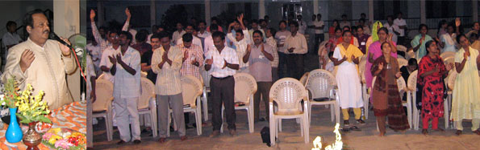

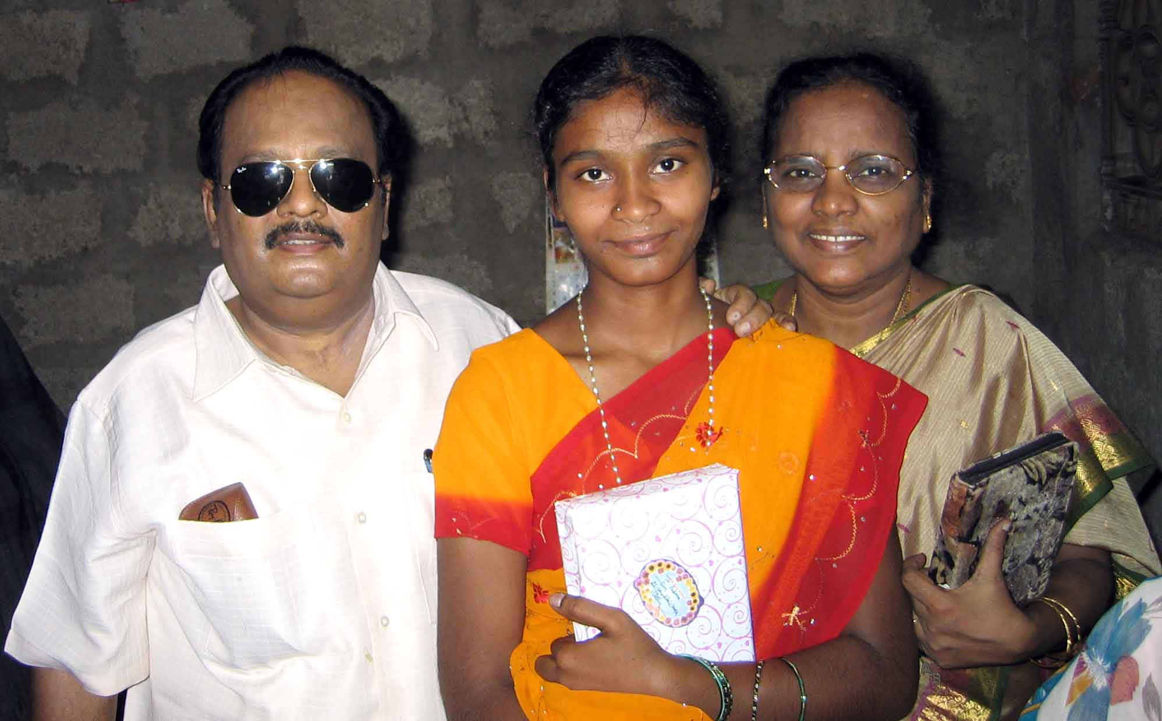
2. The first marriage of the child from our Guntur House Of Hope orphanage Miss Padma has taken place at Mangalagiri. She is a widow’s daughter and doing nursing who is brought up in our orphanage from the childhood. The widow (her mother) has requested us for a help of 500 USD to clear the marriage debts. Please pray and consider.

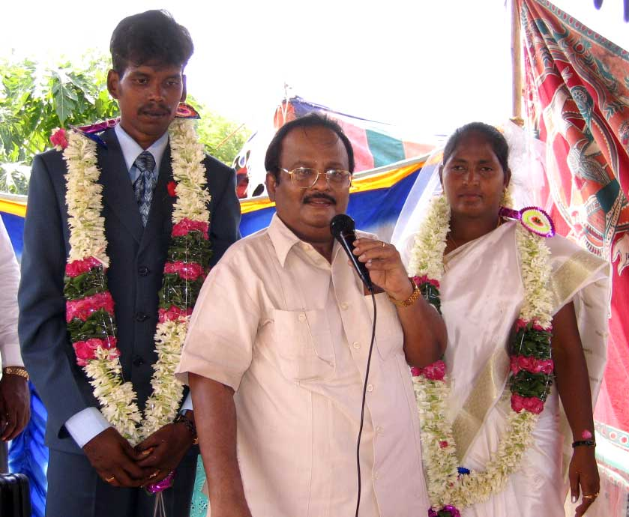

3. Our House Of Hope orphanage warden got married with our gospel van driver whose wedding I have celebrated at Sattenapalli. They are very very poor. They also requested us for some help. Please pray and consider.

4. I have ministered at Hyderabad and other places also even in the ‘Shepherd Church’ annual gospel campaign at Guntur.

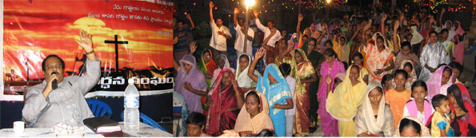

5. Tomorrow I’m going to minister in a wedding ceremony at Atmakur (Kurnool District).
6. Even in this month I’m going to visit God willing Kurnool, Anantapur, Hindupur and
Lepakshi near Bangalore to meet some of our TV viewers personally and encourage them.
7. In the last week of May I’m going to minister 3 days in the ‘Family Conference’ at kakinada.
8. Again in the first week of June I have to visit Rayalaseema region, Vizag and Hyderabad. I
covert your prayers for the ministry. Thanks.

MIRACLES WROUGHT BY JESUS IN OUR MINISTRY THROUGH THE PRAYERS OFFERED BY DR.SANTHAVARDHAN

Note : (Only a few are quoted here among many)
Reporter : Franciana
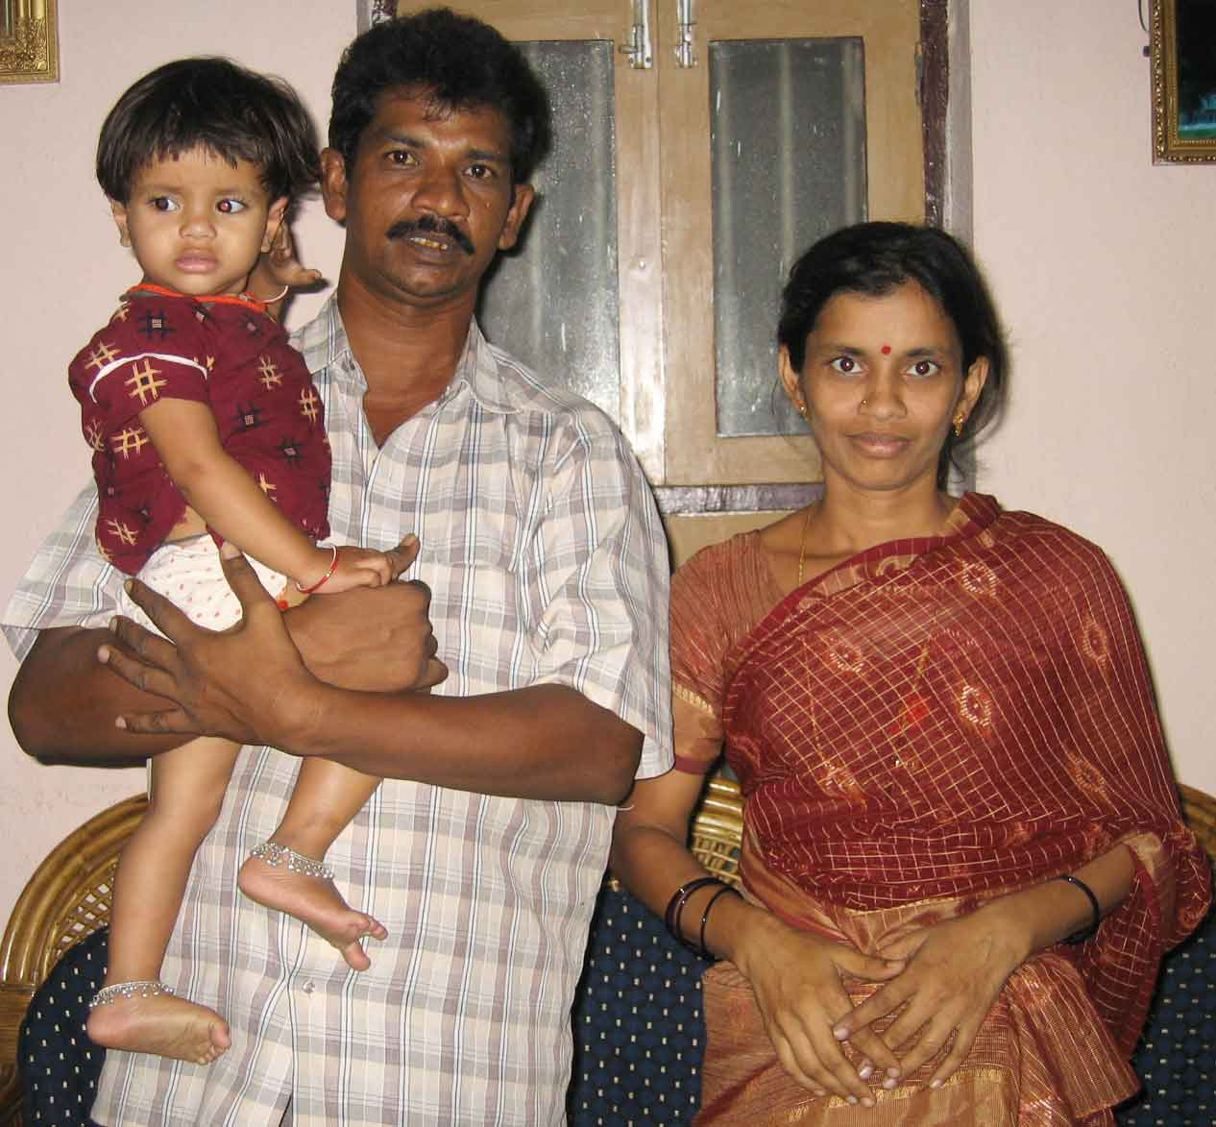
1. Blessed with a child after 17 years of married life : After 17 years of married life because of the powerful prayers of Dr.Santhavardhan garu, Jesus blessed us with a child when all other avenues, medical efforts and other Gods and Goddesses failed to bless us with a child. Now we realize Jesus alone is the true God. We came to know him through his TV programme and through our sister who is the only person who belived Jesus and attended his church El-Shaddai. Her name is Surya Kantham.
--- Ramalingaraju & Rajeswari, Bhimavaram.

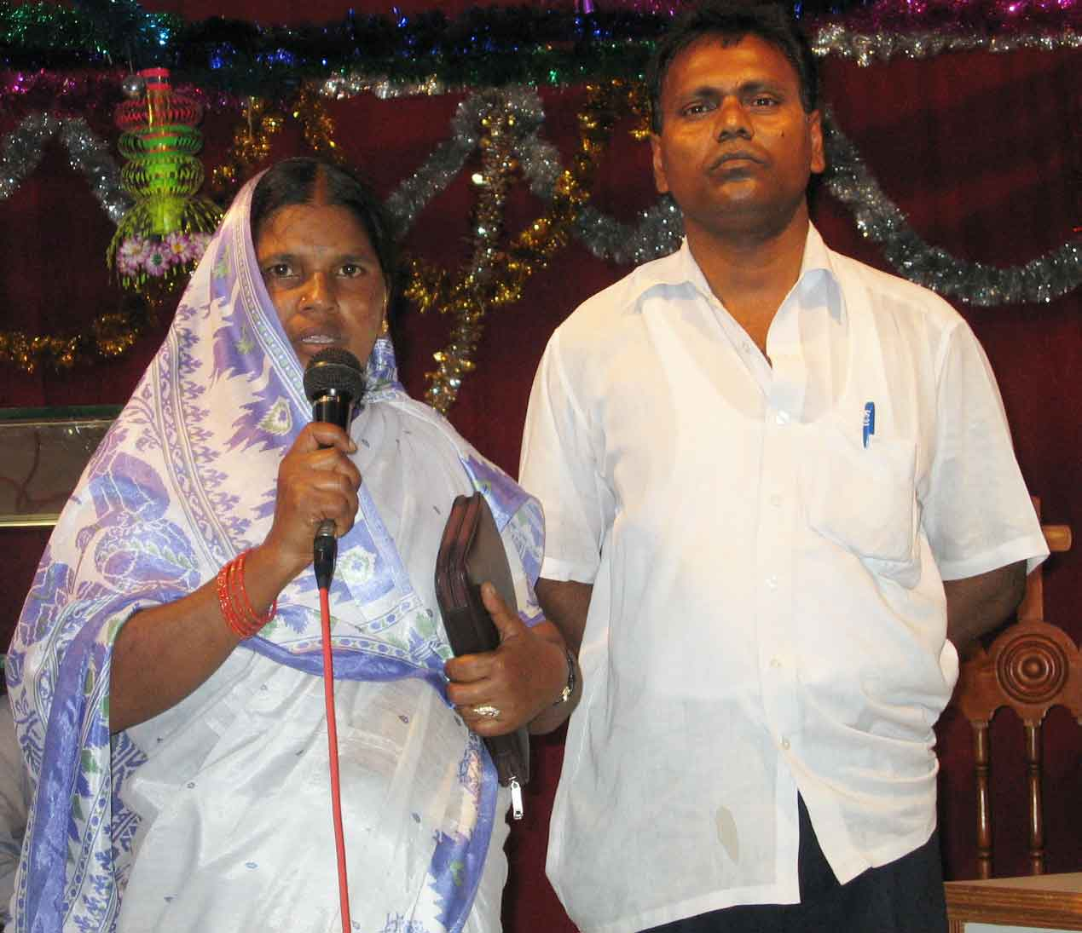

2. Delivered from 9 years of sever epilepsy : My wife has suffered very much with Epilepsy. But Jesus delivered my wife completely through the prayers of Dr.Santhavardhan, we came to know about him through his TV programme. She was like the boy mentioned in mark 9:18. Now she is free from that terrible disease Epilepsy. Now we have decided to do gospel work and win souls for Christ.
--- Mr&Mrs.Immanuel, Hyderabad.

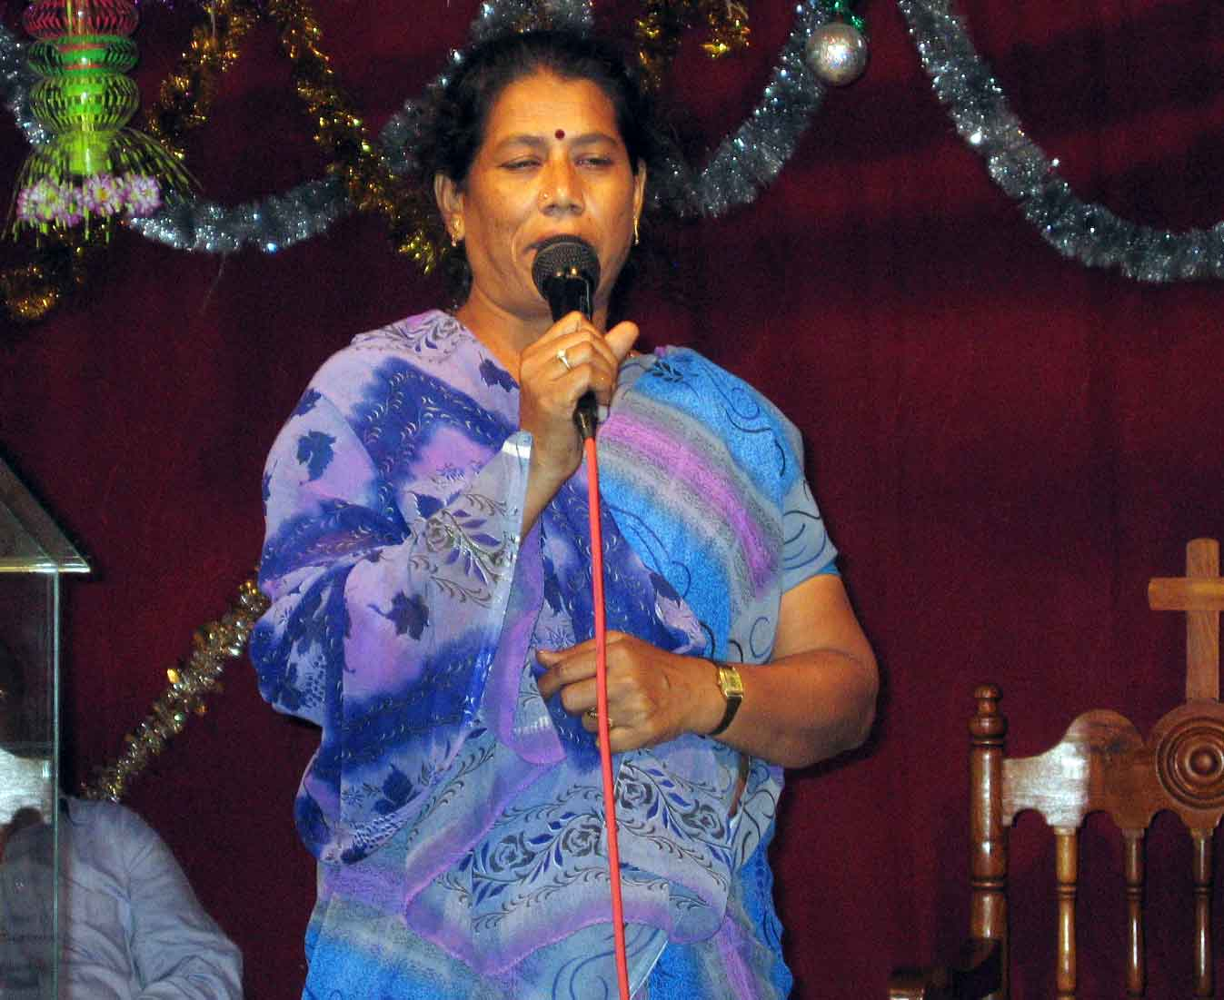
3.Blessed with a new house : We are Hindus. Through Santhavardhan’s prayers God blessed us with a new house when there was no money in our hands. Now we know the power of Jesus Christ. He is a god with true authority. We regularly watch his TV programmes. This miracle has proved to us that Jesus alone has authority to do genuine miracles and bless them that trust him. So we have accepted Lord Jesus Christ as our personal saviour.
--- Smt.Lakshmi, Jaggampet.

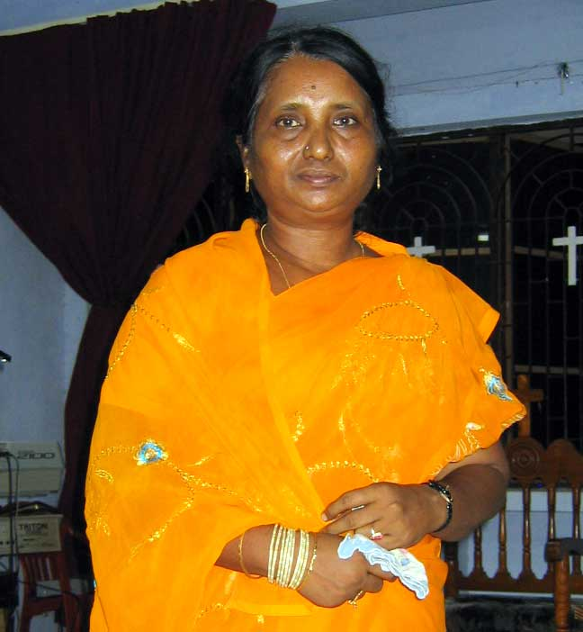
4. Secured seat in Medicine : Only because of the prayers of Dr.Santhavardhan Lord has given high success to my daughter and she secured free seat in the medical college. My Son got 965 marks out of 1000 marks in the intermediate examinations. Several years ago when my husband tried to kill me, I have received many stab injuries. I was dying on the hospital bed. Then Dr.Santhavardhan prayed for me and Lord saved my life. Then I accepted Lord Jesus Christ. Because of his prayers I have forgiven my husband and rejoined him. He is yet to be saved. My 2 children received Jesus and forgiven their dad.
--- Mrs.Padma,Darsi.

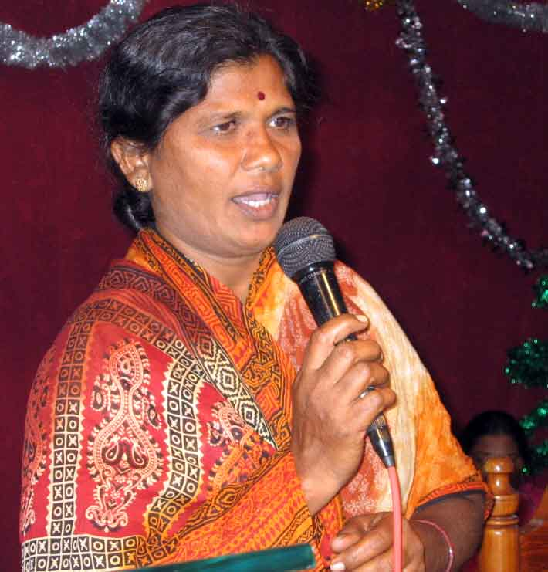
5. Marriage Blessing : We regularly watch the TV programme ‘Adbhutha Ghadiya’ in which Dr.Santhavardhan preaches and prayes for the viewers. We accepted lord Jesus Christ and took baptism. All our Hindu kith and kin heckled at us and said our daughter would never get married as we have converted into Christianity. But because of the powerful prayers of pastor. Santhavardhan Lord has blessed her with a nice person to get married with out ‘Dowry’.
--- Smt.Dwarakamma, Vempadu.

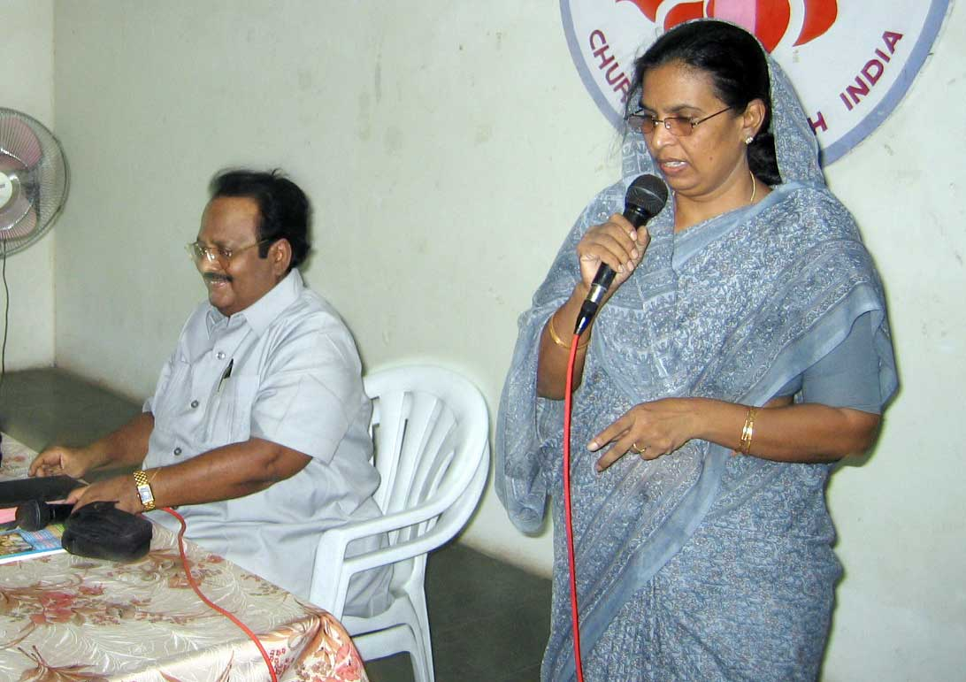
6. One minute prayer by the servent of god healed me and gave me strength to fast & pray for 40 days : As the physicians have administered high dosage of medicine for my hypertension. Suddenly I collapsed and drifted in to semi-comatic conditions and severaly suffered very much with total weakness and infirmity. Almost all for one and a half months I was crawling even to go for a few yards in the house. I have become tatally a wreck. I could not even lift the telephone received from the cradle because I was so much sick and weak even to receive the telephone call. I was fervently praying god to touch and heal me. All of a sudden one night I have received a television call from Dr.santhavardhan.

Through the phone he prayed only for one minute and proclaimed that God has touched and healed me. All praise to our Lord Jesus Christ whose name is ‘wonderful’. I received all divine and physical health with in 10 minutes and raised from my sick bed and started jumping in the joy and praising the Lord.

Remember dear friends, God has given me such strength and energy through the one minute prayer of Dr.Santhavardhan over the telephone. From the very next day I have fasted for 40 days (I took only a very little breakfast during the morning time. That’s all) praying and praising and specially praying for the TV programmes and Good News Messengers ministries. I pray God to bless his chosen vessel more and more with good health and long life so that he may be a continuous blessing to people like me and to specially win souls for Christ specially from the heathen. Because of his prayers Lord has blessed my two sons in their studies and one is working in the USA.
--- Mrs.P.D.Kumari, Vijayawada.

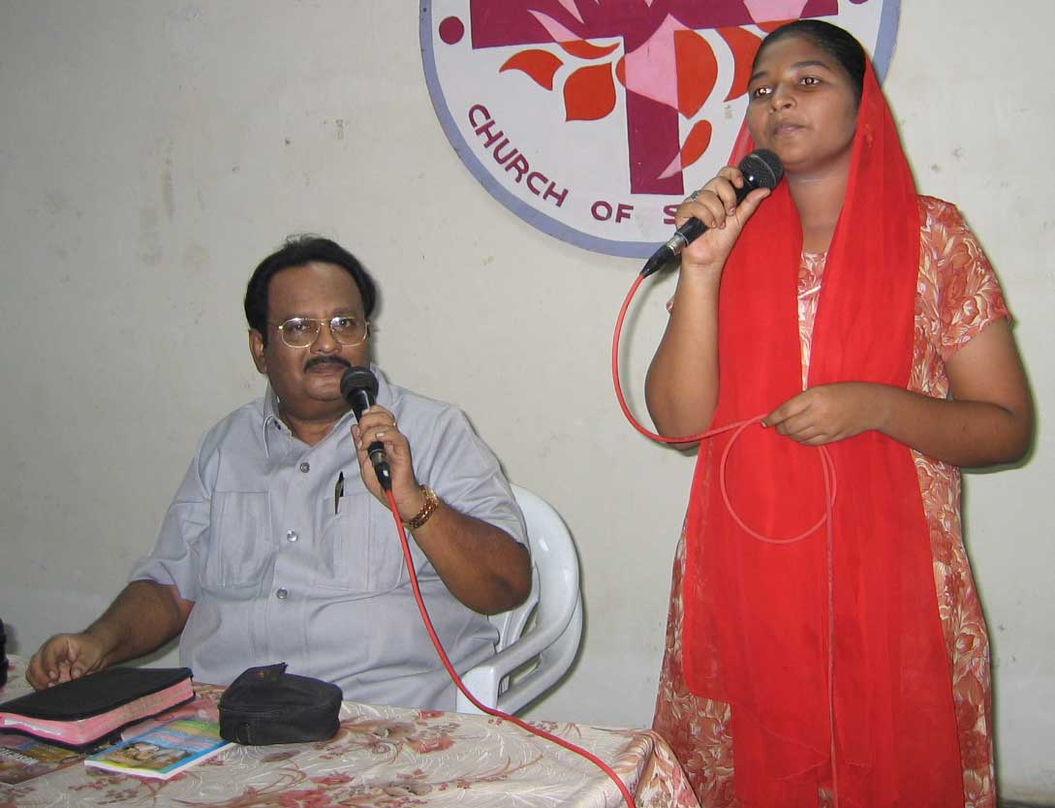
7. Miraclous Healing : I’m a Hindu lady residing in the state of Assam originally from Andhra. I was very much suffering with terrible tumors in both of my breasts. I went for medical help. The medical doctors removed the tumors through surgery and again after sometime they re-appeared in my two breasts. Then again I went to the medical doctors and also offering special pujas (prayers) to several of our so called Gods & Goddesses, but in vain. The medical surgeons have again removed the tumors through surgery. Twice they have operated on me but again after a little time the tumors have appeared again in my breast. Doctors have given up hope. I was very much depressed and thought that death would be better for me. There was no way out for my cure under the sun.

But suddenly one day I happened to watch the TV programme of Dr.Santhavardhan accidently. His message about the power of Jesus Christ moved me like anything. I thought may be Jesus is the only true god who is the same yesterday, today & for ever as the preacher is preaching. At the end of the message Dr.Santhavardhan has offered a prayer for salvation and also for other blessing. While he was praying on the TV, I kept one hand upon my two breasts and lifted up another hand to Jesus in the heaven and agreed with the preacher in that prayer. Wonder! Suddenly a great miracle has taken place.
When I examined the two breasts after the prayer there were no tumors in my two breasts. No trace of them even. By the simple prayer of the preacher they simply disappeared even with out surgery with in a few minutes. I have waited for 3 years to see if the tumors reappear. No, there is no trace of them and I’m tatally healed by Jesus. Now I’m convinced that Jesus is the true God and the Lord of all flesh. Please pray so that my other family members also may come to Jesus through this miracle. I came all the way from Assam to Andhra and giving this open testimony in the All evening meeting held by Dr.Santhavardhan specially for his TV programme viewers and others at vijayawada on 19th May 2007.
--- Mrs.G.Madavilatha, Assam.

These are some of the open testimonies given by our TV programme viewers in the All Night prayer Held in Guntur on 12th May and in the All Evening prayer held at Vijayawada on 19th May 2007.

Again our ‘Adbhutha Ghadiya’ TV programmes in the
‘MAA’TV Channel


Though very expensive we have come back to ‘MAA’ TV channel for televising our Adbhutha Ghdiya programmes for wider range. It seems these programmes appear even in USA provided you have the Dish antenna.

To televise this programme for one year we need 75 persons who can donate atleast 50USD every month through out the year. We plead with you to become partners in this noble programme.

www.maatv.com

You can even get tax deductible receipts in US by sending this money for the Good News Messengers through the following address.

May God bless you and all of yours and provide your every need richly in his grace.

YOUR HELP

YOU CAN SEND YOUR CHEQUES IN THE NAME OF ‘GOOD NEWS MESSENGERS’ AND MAIL THEM DIRECTLY TO THE FOLLOWING ADDRESS BY REGISTERED MAIL.

REV.DR.M.S.SANTHA VARDHAN
DIRECTOR,
GOOD NEWS MESSENGERS
‘EL-SHADDAI’ CHURCH
KANNAVARITHOTA 4TH LANE
GUNTUR-522004.
SOUTH INDIA

TELEPHONE: 011-91-863-2354536.
CELL PHONE: 9848113886.

YOU CAN DIRECTLY SEND THE MONEY BY MAIL TRANSFER TO OUR BANK ACCOUNT IN INDIA.

SWIFT CODE: SBI NIN BB 181
ACCOUNT NO: 10949477027

DONORS IN USA
to get the tax deductible receipts may send their cheques in the name of
CALVARY LIFE FELLOWSHIP.
(for Good News Messengers in India)
to the following address:
CALVARY LIFE FELLOWSHIP,
P.O.BOX: 1161, BREA,
California—92822,USA

For any other details about our ministry please contact
Merlyn in USA Tel:817-657-5689.
E-mail:dolly_mv@yahoo.com.

Thanking you very much.
Cordially yours in Christ,
Dr.M.S.Santha Vardhan.
Director:Good News Messengers.

www.goodnewsmessengers.org

