POST BOX- 306, KANNAVARITHOTA 4th LANE

GUNTUR (A.P) - INDIA – 522004
Email- Santhavardhan@yahoo.com www.goodnewsmessengers.org

Phone – 011-91-863-2354536

News Letter
June & July - 2007

Dr.M.S.Santhavardhan
DIRECTOR
MESSAGE TITLE: VARIOUS TESTIMONIES GIVEN ABOUT JESUS
MESSAGE OUTLINES
- TESTIMONY GIVEN BY THE HEAVENLY FATHER ‘THIS IS MY BELOVED SON IN WHOM I AM WELL-PLEASED’ (MATHEW 3 : 17)
- TESTIMONY GIVEN BY THE HOLY SCRIPTURES
‘ GOD’S SON SHINES OUT WITH GOD’S GLORY AND ALL THAT GOD’S SON IS AND DOES
MARKS HIM AS GOD’ ( HEBREWS 1:3)- LIVING BIBLE
- TESTIMONY GIVEN BY THE DEMONS (DEMON-POSSESSED MEN) ‘HE IS THE SON OF THE MOST HIGH GOD’ ( MARK 5:7) ‘HE IS THE HOLY ONE OF GOD’ ( LUKE 4:34)
- TESTIMONY GIVEN BY JOHN THE BAPTIST
‘HE IS THE LAMB OF GOD’ (JOHN 1:36; HEB 10:4 & 12-14; JOHN 10:18; ROM 5:6-11)
- TESTIMONY GIVEN BY PROPHET ISAIAH
‘ HIS NAME IS ……. MIGHTY GOD’ ( ISAIAH 9:6)
- TESTIMONY GIVEN BY SIMON PETER , HIS DISCIPLE
‘ HE IS THE CHRIST, THE SON OF THE LIVING GOD’ (MATHEW 16:16)
- TESTIMONY GIVEN BY ST. PAUL WHO WAS ONCE AN ARCH RIVAL AND ENEMY TO CHRISTIANITY
‘ GREAT GOD AND SAVIOUR’ (TITUS 2:13; JOHN 6: 69)
- TESTIMONY OF THE CENTURION WHO HEADED THE TEAM OF SOLDIERS WHO CRUCIFIED JESUS
‘ SURELY HE WAS THE SON OF GOD’ ( MARK 15:39)
- TESTIMONY GIVEN BY JOHN, HIS BELOVED DISCIPLE
‘ HE IS GOD THE WORD WHO BECAME FLESH’( JOHN 1:1-4 ; JOHN 1:14)
- TESTIMONY GIVEN BY PONTIUS THE PILATE AND HIS WIFE
- HE IS SINLESS ( JOHN 19:5)
- HE IS RIGHTEOUS (MATHEW 27:13)
- YES!NONE OTHER THAN JESUS IS RIGHTEOUS(ROM 3:11; MARK 10:15)
- TESTIMONY GIVEN BY THE SAMARITAN WOMAN ‘ TRULY HE IS CHRIST THE MESSIAH’ ( JOHN 4:29)
- TESTIMONY GIVEN BY THE SAMARITAN PEOPLE
‘ TRULY HE IS THE SAVIOUR OF THE WORLD’ ( JOHN 4:42)( 1 THY 1:15)
- TESTIMONY GIVEN BY JESUS HIMSELF
‘ I AM THE ALPHA AND THE OMEGA’ SAYS THE LORD GOD WHO IS AND WHO WAS AND WHO
IS TO COME , THE ALMIGHTY. ( REVE 1:8 & 18 ; 22 :13)

WHOM DO YOU THINK JESUS IS ?
YOU HAVE REALIZED BY THESE TESTIMONIES THAT JESUS ALONE IS THE ONLY TRUE GOD AND SAVIOUR, HAVE YOU TAKEN HIM IN YOUR HEART AS YOUR PERSONAL SAVIOUR AND LORD? IF NOT, RIGHT NOW INVITE HIM INTO YOUR HEART AND BE SAVED.
(HEB 3: 13-15) & (11 CORINTHIANS 6:2)

POLICE CHIEF LAUDED THE SERVICES OF GOOD NEWS MESSENGERS

SRI. SANJAY I.P.S PRINCIPAL, POLICE TRAINING COLLEGE, ANANTAPUR WAS THE CHIEF GUEST FOR THE MEETING AT PENUKONDA TOWN IN ANANTAPUR DISTRICT NOTORIOUS FOR CRIMES AND FACTIONISM. GOOD NEWS MESSENGERS HAS ARRANGED THIS MEETING THROUGH REV. DR. VARAPRASADA RAO IN THE ZION CHURCH GROUNDS WHERE DR. SANTHAVARDHAN AND MRS.NIRMALA SANTHAVARDHAN HAVE GIVEN THEIR TESTIMONIES AND PREACHED THE GOSPEL OF JESUS CHRIST. INTERNATIONALL FAMOUS HINDHU GOD-MAN SATHYA SAIBABA LIVES IN A NEAR BY TOWN.

THE CHURCH GROUNDS WERE FULL WITH PEOPLE WHO CAME FROM THE NEAR BY VILLAGES AND LOCAL TOWNS. ALMOST ALL THE HIGH OFFICIALS OF THE TOWN IRRESPECTIVE OF THEIR CASTE AND COMMUNITY ATTENDED THE MEETING WITH THEIR FAMILIES TO HEAR THE WELL NOTED SPEAKER DR.SANTHA VARDHAN. THE MESSAGE OF DR.SANTHAVARDHAN SUPPLEMENTED BY THE TESTIMONY GIVEN BY HIS WIFE ABOUT THE ALMIGHTY POWER OF THE LIVING GOD JESUS CHRIST MOVED THE HEARTS OF THE PEOPLE AND THE 95% OF THE CONGREGATION RESPONDED TO THE ALTAR CALL ND THEY HAVE GIVEN THEIR HEARTS TO THE LORD.

THE HIGH POPULAR POLICE CHIEF WHO ONCE WORKED IN HYDERABAD AND SECUNDERABAD AS DEPUTY POLICE COMMISSIONER APPRECIATED THE MESSAGES AND THE GOOD NEWS MESSENGERS MINISTRIES AND OPENLY DECLARED THAT JESUS CHRIST ALONE IS THE SAVIOUR OF THE WORLD AND SUCH MEETINGS DEFINITELY BRING DOWN THE CRIME RATE IN THE CITY.

HE PARTICIPATED IN THE MEETING WITH HIS ENTIRE FAMILY INSPITE OF HIS BUSY SCHEDULE AND INVITED DR. SANTHAVARDHAN AND HIS TEAM. NEXT DAY TO HIS BUNGALOW AND GAVE THEM WONDERFUL HOSPITALITY. HIS WIFE GAVE NEW CLOTHES TO THE FEW ORPHAN CHILDREN WHO ACCOMPANIED THE SPEAKER COUPLE. PRAISE BE TO GOD!

FOR THE OPEN PROCLAMATION AND TESTIMONY GIVEN BY THIS HIGHLY EFFICIENT POLICE DIGNITARY WHO IS PRESENTLY WORKING AS THE PRINCIPAL OF POLICE TRAINING COLLEGE, ANANTAPUR IS WONDERFUL. MUSIC WAS PROVIDED IN THE MEETING BY ONE OF THE MUSIC PASTORS OF GOOD NEWS MESSENGERS MR. DAVID WITH HIS TEAM. THE LORD HAS GIVEN GRACE TO DR.SANTHAVARDHAN COUPLE TO TRAVEL MORE THEN 1000 MILES IN THIS TRIP BY THE GOSPEL VAN.
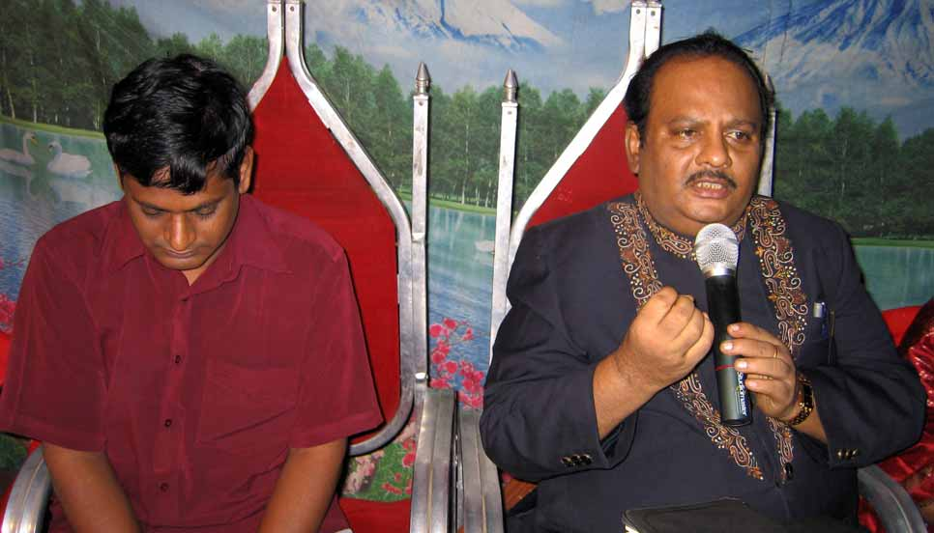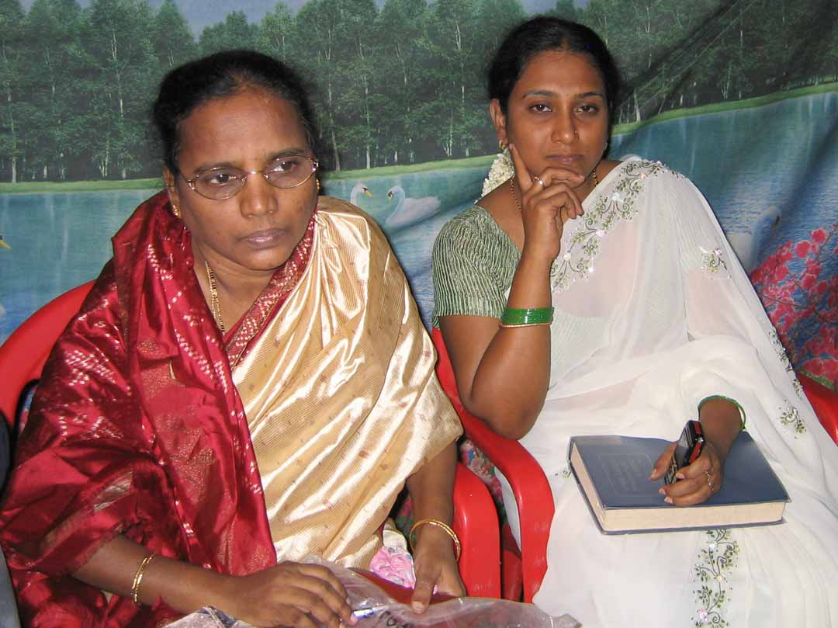
Penukonda meetings,Chief guest, principal,police trainging college Mr.Sunjay IPS & Dr.Santhavardhan

Police chief’s wife Mrs.Mohitha Sunjay
with Mrs.Nirmal Santhavardhan

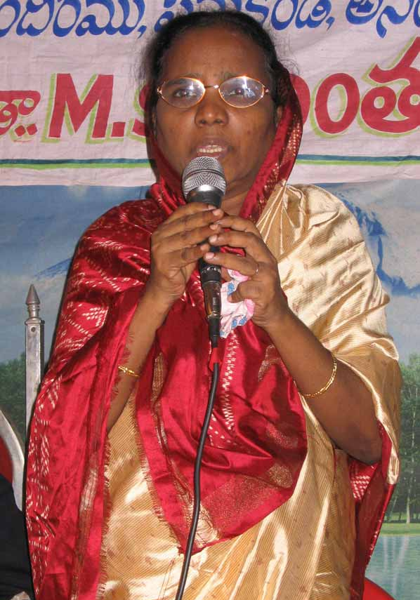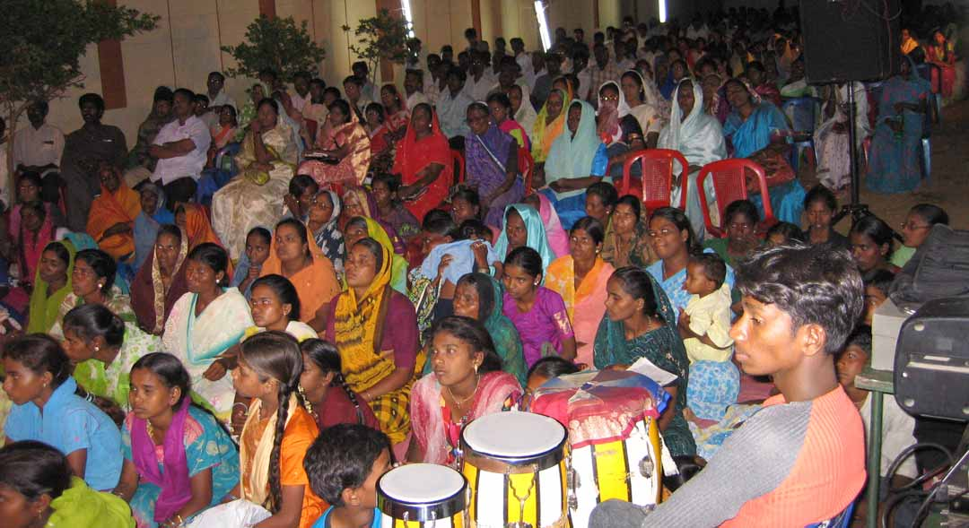
Testimony cum Preaching

Church grounds filled with crowd

ENTIRE TOWN OF HINDUPUR MOVED FOR CHRIST

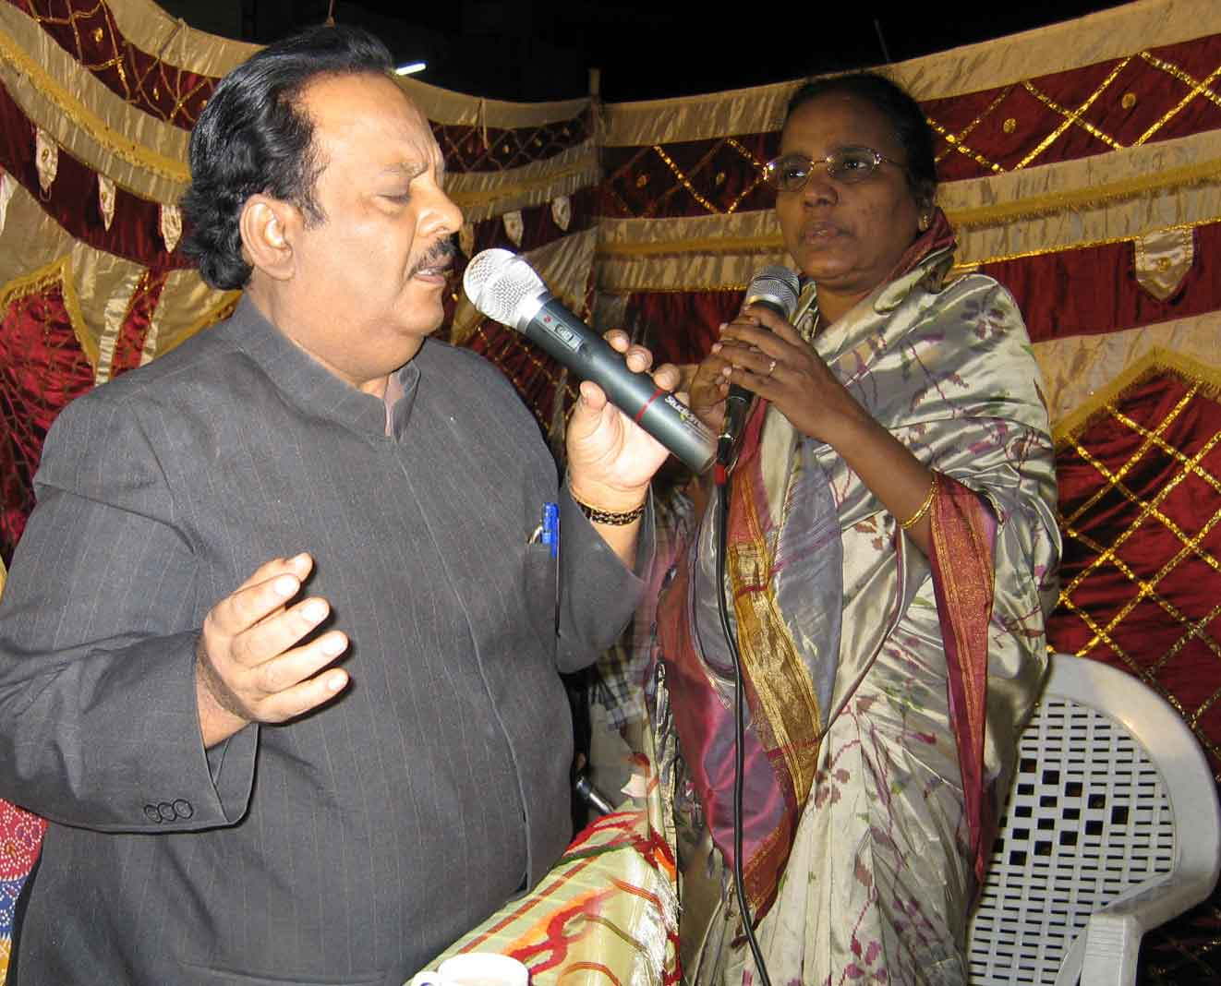
EXACTLY 35 YEARS AGO DR.SANTHAVARDHAN COUPLE BEGAN THEIR MINISTRY IN A TOWN KNOWN AS HINDUPUR WHICH IS IN BETWEEN ANANTAPUR AND BANGALORE CITIES. AFTER 35 YEARS THE CHURCH IN WHICH THEY HAVE MINISTERED ONCE INVITED THEM FOR A VERY BIG OPEN GOSPEL MEETING IN THE TOWN WHERE SOME STRONG HINDU FANATICS LIVE WHO FRIGHTEN THE CHRISTIAN COMMUNITY WITH THEIR SPEECHES AND ACTIONS.
Dr.Santhavardhan & Mrs.Nirmala Santhavardhan preaching

THOUGH THE PALEM CHURCH IS VERY VERY POOR THEY GAVE THEIR DAILY WAGES AND ARRANGED THE MEETING IN THE MUNICIPAL HIGH SCHOOL GROUNDS PARK WHERE PEOPLE THRONGED TO HEAR DR.SANTHAVARDHAN. GENERALLY IN THIS TOWN CHRISTIANS WOULD NEVER VENTURE TO ORGANISE GOSPEL MEETINGS IN PUBLIC PLACES. THEIR MEETINGS ARE ONLY LIMITED AND CONFINED TO THEIR CHURCH BUILDINGS OR GROUNDS. BUT THE FAITH STEP TAKEN BY THIS POOR PALEM CHURCH YIELD WONDERFUL RESULTS. MANY HINDUS FLOCKED TO THE MEETINGS AS MUCH PUBLICITY WAS GIVEN BY THIS CHURCH MEMBERS AND ALSO THROUGH OUR TELEVISION PROGRAMMES ABOUT THE MEETING. SEVERAL LOCAL CHURCH PASTORS FASTED, SHED TEARS AND PRAYED FERVENTLY FOR THE SUCCESS OF THE MEETING. A VERY BIG MUSIC BAND WHO SANG SPIRITUAL SONGS WRITTEN BY DR.SANTHAVARDHAN MADE THE PEOPLE JOYFUL AND HILARIOUS. DR.SANTHAVARDHAN HAS PREACHED, SANG AND OFFERED SPECIAL PRAYERS WHILE HIS WIFE ALSO GAVE TESTIMONY AND PREACHED SPECIALLY AIMING AT THE HINDU WOMEN WHO ATTENDED THE MEETING IN GREAT NUMBER WITH GREAT CURIOSITY. AS A RESULT ATLEAST 1000 PERSONS AMONG THE HEATHEN HAVE ACCEPTED LORD JESUS CHRIST AS THEIR PERSONAL SAVIOUR IN THIS MEETING. ALL GLORY TO JESUS.

A POOR WIDOW WHOSE HUSBAND WAS VERY MUCH BENEFITED BY THE MINISTRY OF DR. SANTHA VARDHAN THIRTY FIVE YEARS AGO CAME FORWARD TO GIVE HER LAND AT A THROW AWAY PRICE TO GOOD NEWS MESSENGERS PROVIDED HEY CONSTRUCT A CHURCH BUILDING IN MEMORY OF HER DISEASED EVANGELIST CUM LABORER HUSBAND AND ALSO CONSTRUCT A OLD AGE HOME FOR DESTITUTE LIKE HER.

DR.SANTHAVARDHAN COUPLE ALSO VISITED THE KIDS OF CHRIST IN THE HOUSE OF HOPE ORPHANAGE AT ANANTAPUR CITY ON THEIR WAY BACK TO GUNTUR. IN THIS TRIP ALSO THEY HAVE NEARLY COVERED A LITTLE MORE THAN 1000 MILES ALMOST ALL TOUCHING THE BORDER CITY OF KARNATAKA, BANGALORE.

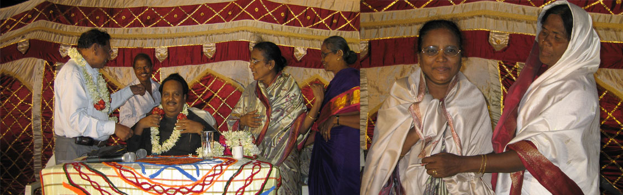
Felicitations to Dr.Santhavardhan & Mrs.Nirmala santhavardhan

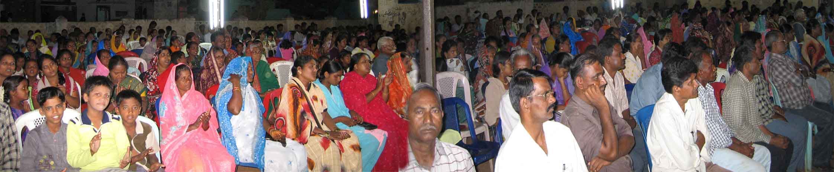
Municipal school grounds packed with people

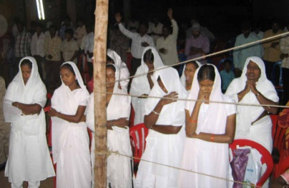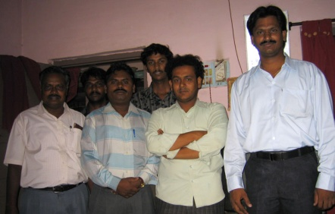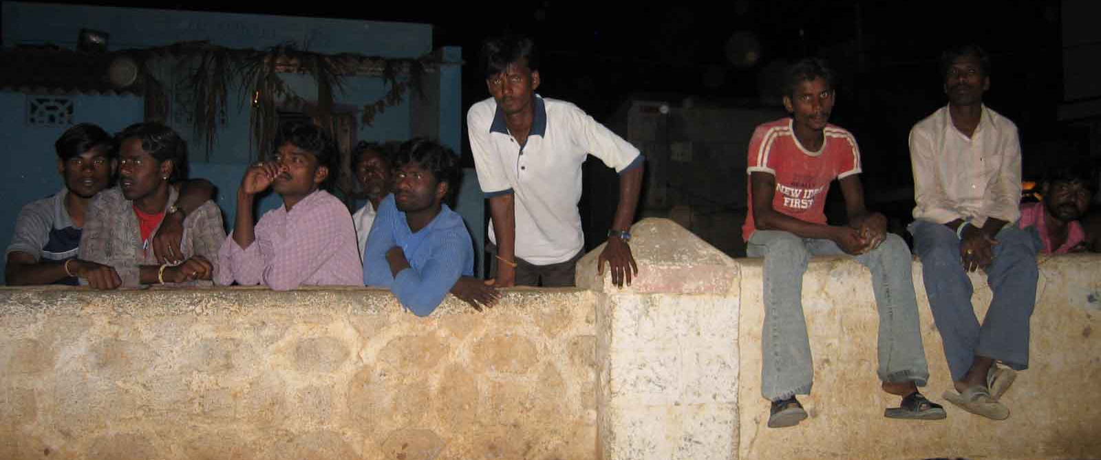
Some of the Choir girls
Some of the Ushers
Youngsters sitting on the compound walls
Keenly listening to the Gospel

ALL INDIA PRAYER DAY CELEBRATIONS

ALL INDIA PRAYER DAY WAS CELEBRATED IN GUNTUR, ANDHRA PRADESH UNDER THE LEADERSHIP OF UNITED PASTORS FELLOWSHIP TO WHICH 200 CHRISTIAN CHURCHES ARE AFFILIATED. DR.SANTHA VARDHAN WAS INVITED AS A SPECIAL SPEAKER WHO EDIFIED THE GATHERING AND PRAYED FOR VARIOUS ISSUES CONFRONTING THE CHRISTIAN COMMUNITY IN INDIA. THE GATHERING HAS UNANIMOUSLY CONDEMNED THE DRACONIAN LAWS PASSED BY VARIOUS STATE GOVERNMENTS IN INDIA INCLUDING ANDHRA PRADESH PROHIBITING AND DISCOURAGING CONVERSIONS IN INDIA.
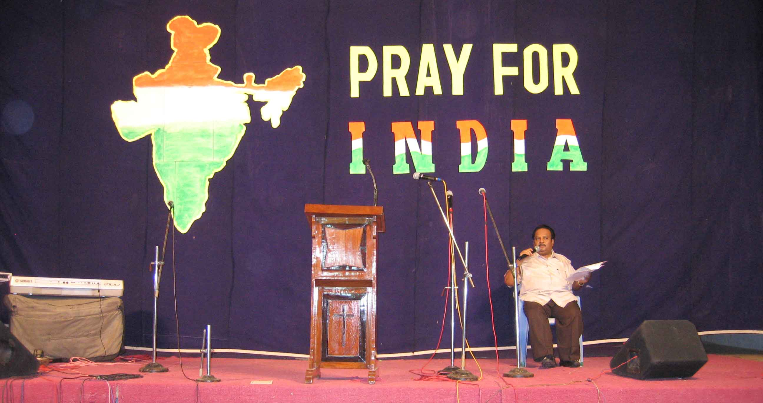

STATE FAMILY CONFERENCE AT KAKINADA

DR.SANTHAVARDHAN HAS PARTICIPATED IN THE STATE FAMILY CONVENTION ARRANGED IN KAKINADA, THE PORT CITY BY CALVARY PRAYER FELLOWSHIP OF KAKINADA FOR 3 DAYS. APART FROM THE BIBLE TEACHINGS IN THE MORNING HE PREACHED EVEN IN THE EVENING PUBLIC MEETINGS ALONG WITH HIS SON JAKIE, THE MUSIC PASTOR. AS A RESULT THERE WAS A GREAT REVIVAL AND THE LORD HAS BLESSED THE CAMPAIGN WITH GREAT REVIVAL.

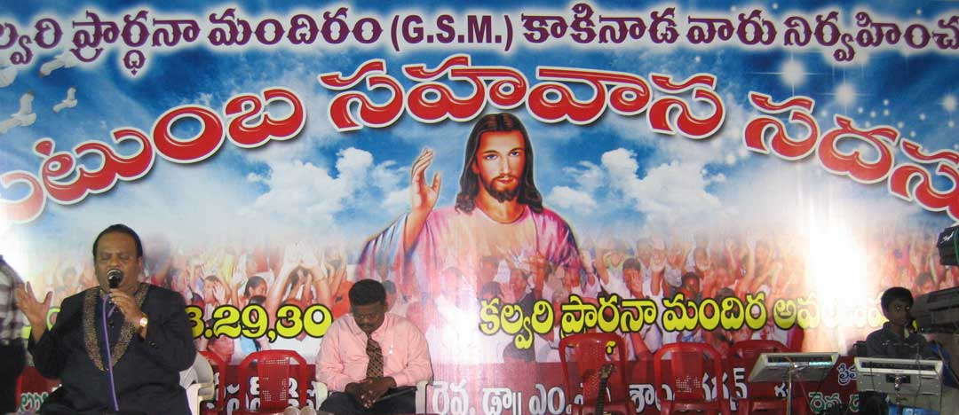
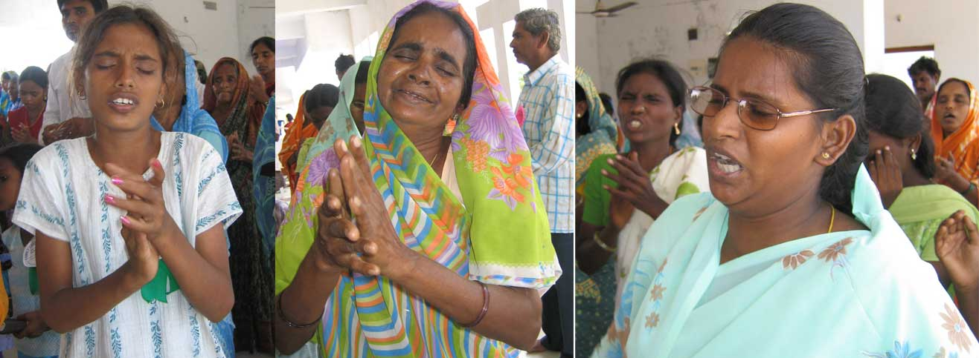
- Youngsters repented for their sins
- Even very old women offered tear filled prayer for revival
- Women shed tears for their families

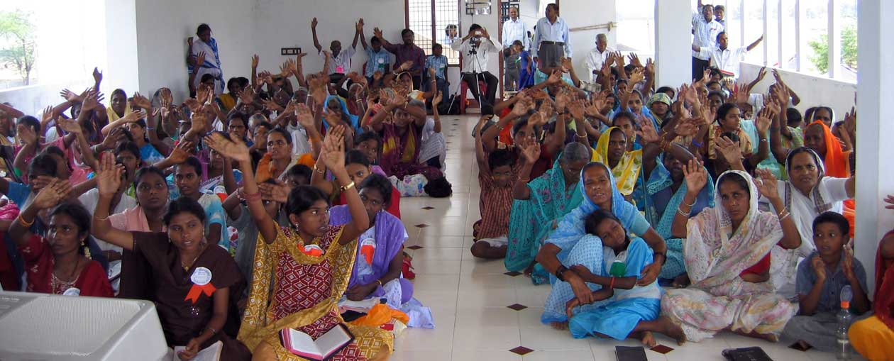

MESSAGES IN THE MARRIAGE CELEBRATIONS

DR.SANTHAVARDHAN TRAVELLED LONG DISTANCES AND PARTICIPATED IN 3 MARRIAGE CELEBRATIONS IN 3 DIFFERENT PARTS OF THE STATE GAVE WEDDING MESSAGES AND BLESSED THE COUPLE.
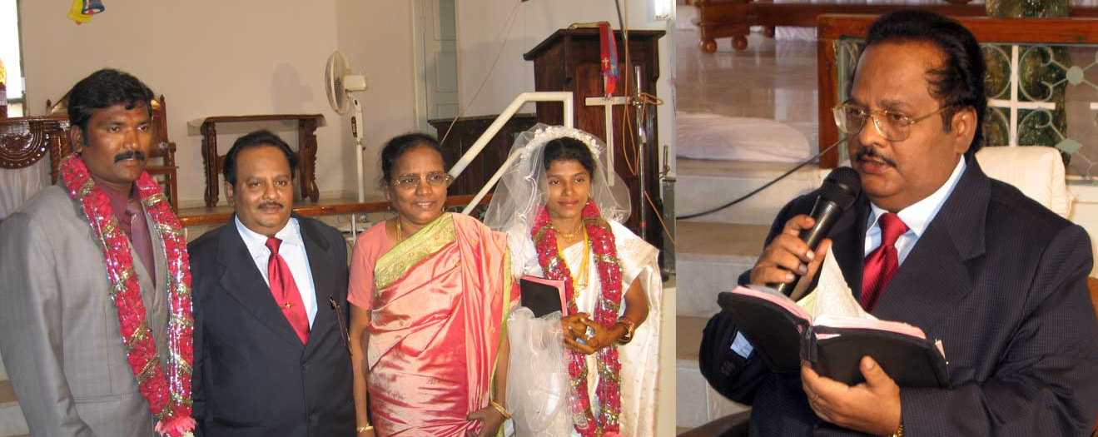
HOUSE OF HOPE SUPERINTENDENT’S MARRIAGE AT
ANANTHAPUR

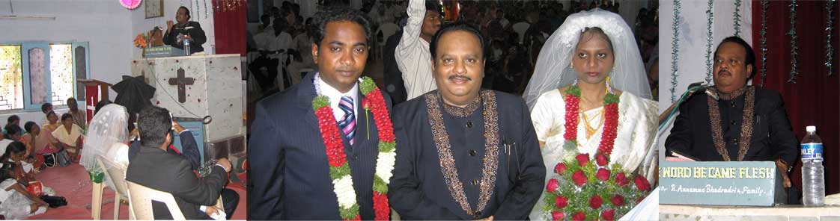
NRI SOFTWARE ENGINEER, SOLOMON’S MARRIAGE AT NALGONDA

HINDU CONVERT VARAPRASAD’S MARRIAGE AT UYYUR-KRISHNA(DT)

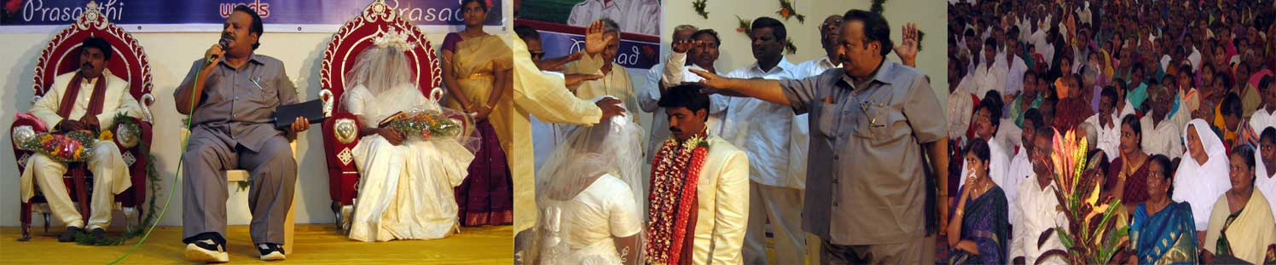

SPECIAL GOSPEL MEETING AT VIZAG

IN THE MIDST OF HEAVY RAINS ALL THROUGH THE STATE BECAUSE OF THE DEPRESSION IN THE BAY OF BENGAL WE HAVE PRAYERFULLY VENTURED TO ORGANIZE A TWO DAY MEETING AND MEET THE ‘ADBUTHA GHADIYA’ T.V PROGRAMME VIEWERS IN THE VIZAG CITY IN THE Y.M.C.A AUDITORIUM. LORD HAS MIRACULOUSLY DID NOT ALLOW RAIN TO FALL IN THE CITY ON THOSE 2 DAYS. IT WAS SUCH A GREAT MIRACLE TO THE LOCAL PEOPLE. EVEN THE YOUNGSTERS WHO WERE WOUNDED IN THE MOTOR-BIKE ACCIDENT DID NOT CARE FOR THE BLEEDING WOUNDS BUT STRAIGHT AWAY CAME FROM THE HOSPITAL AND PARTICIPATED IN THE MEETINGS. THE LORD HAS BLESSED ALL THE PARTICIPANTS. THE VIZAG PORT CITY PEOPLE ARE DEMANDING TO CONSTRUCT A PRAYER HOUSE THERE AND TO ATLEAST CONDUCT MONTHLY MEETING REGULARLY. PLEASE PRAY.
THE Y.M.C.A ADMINISTRATOR FELT SO VERY BLESSED BY PERMITTING US TO HOLD THE MEETING IN THEIR AUDITORIUM SO THEY DID NOT CHARGE ANYTHING FOR THE Y.M.C.A AUDITORIUM AND EVEN FOR THE LODGING ROOMS OF DR.SANTHAVARDHAN AND HIS TEAM IN THEIR GUEST HOUSE. PRAISE GOD AND THANKS TO THE VIZAG Y.M.C.A PRESIDENT OF THE Y.M.C.A UNIT SRI. ROLLAND WILLIAMS WHO ACTUALLY PAID THE ENTIRE BILL FROM HIS POCKET. MAY GOD BLESS HIM AND ALL HIS RICHLY.

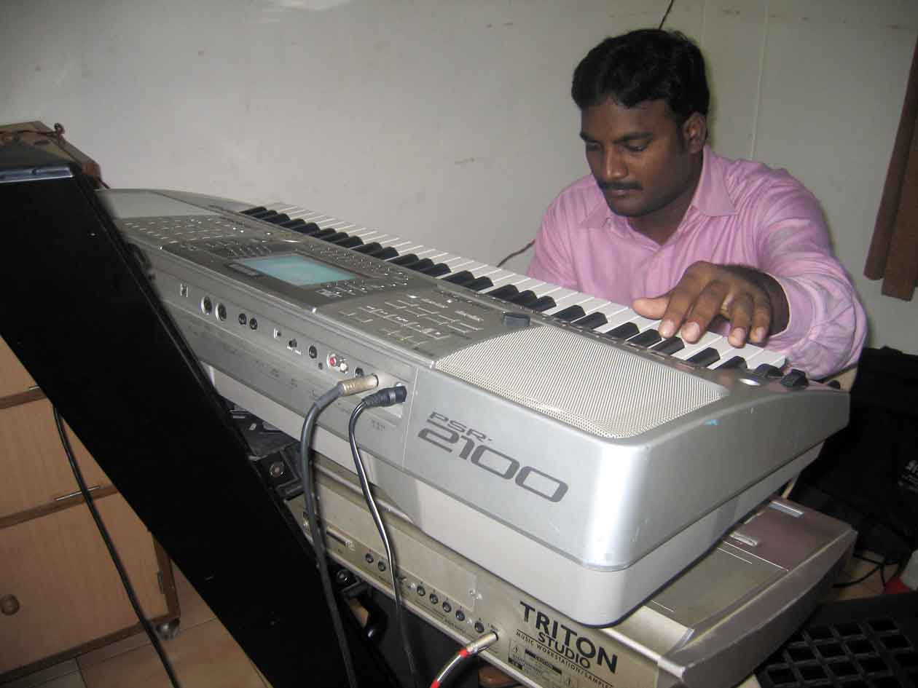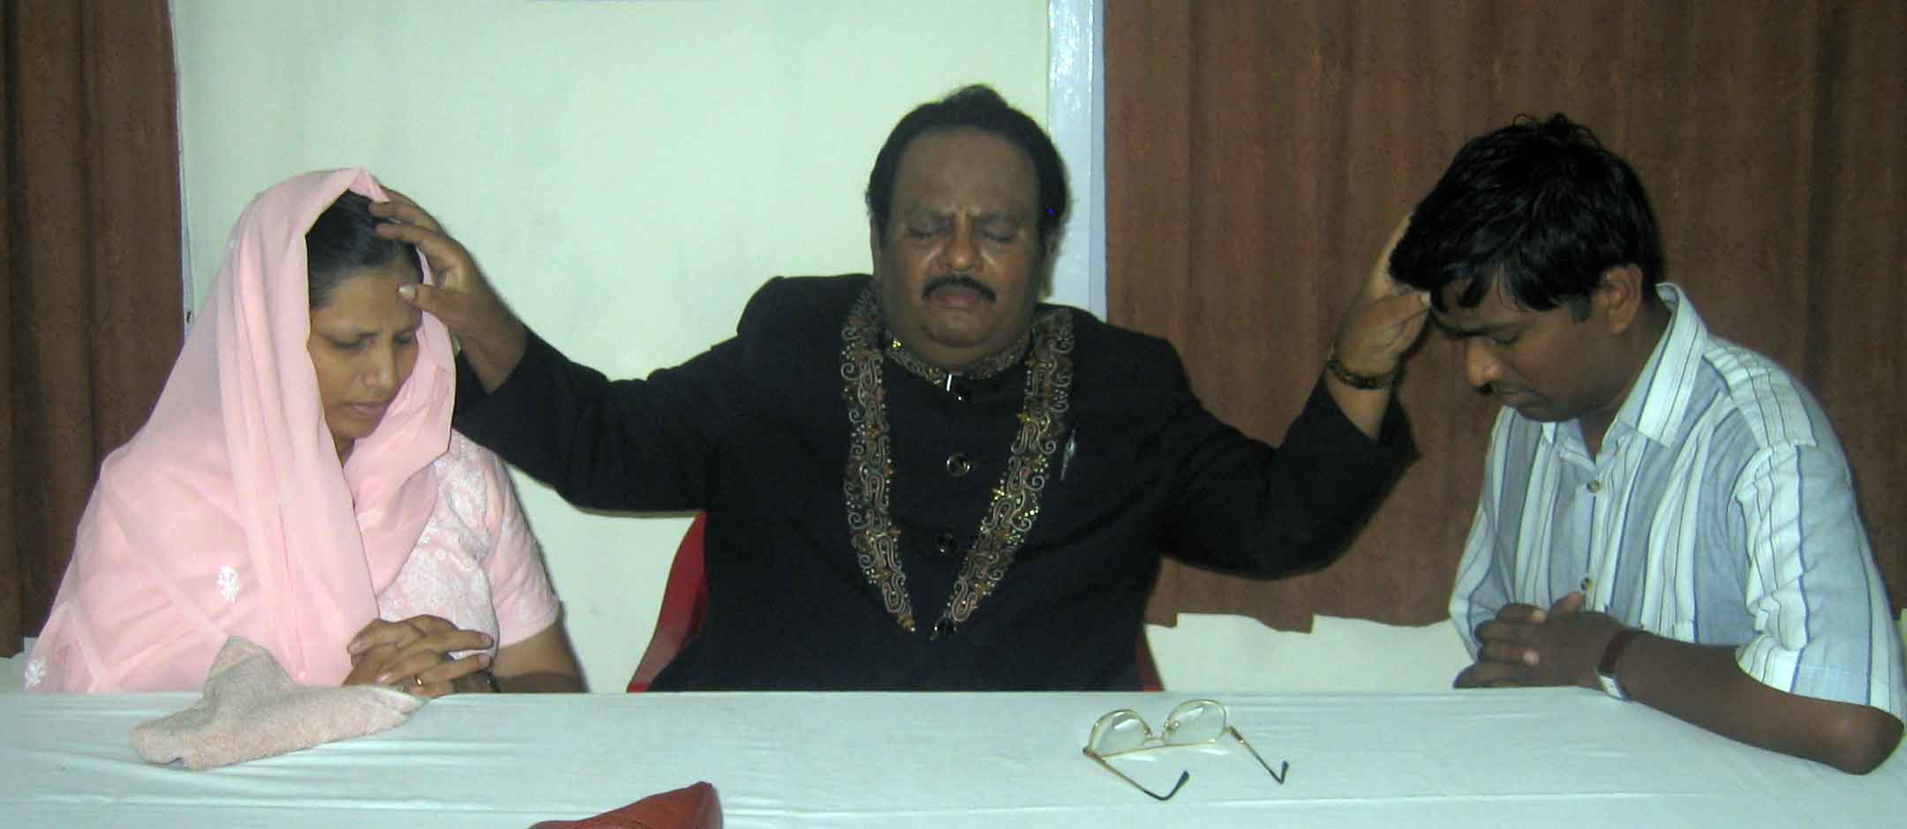
Wonderful Music provided by JAKIE & Team
Special prayer to the computer professor & his wife medical doctor

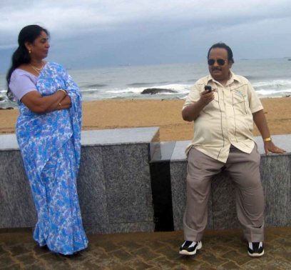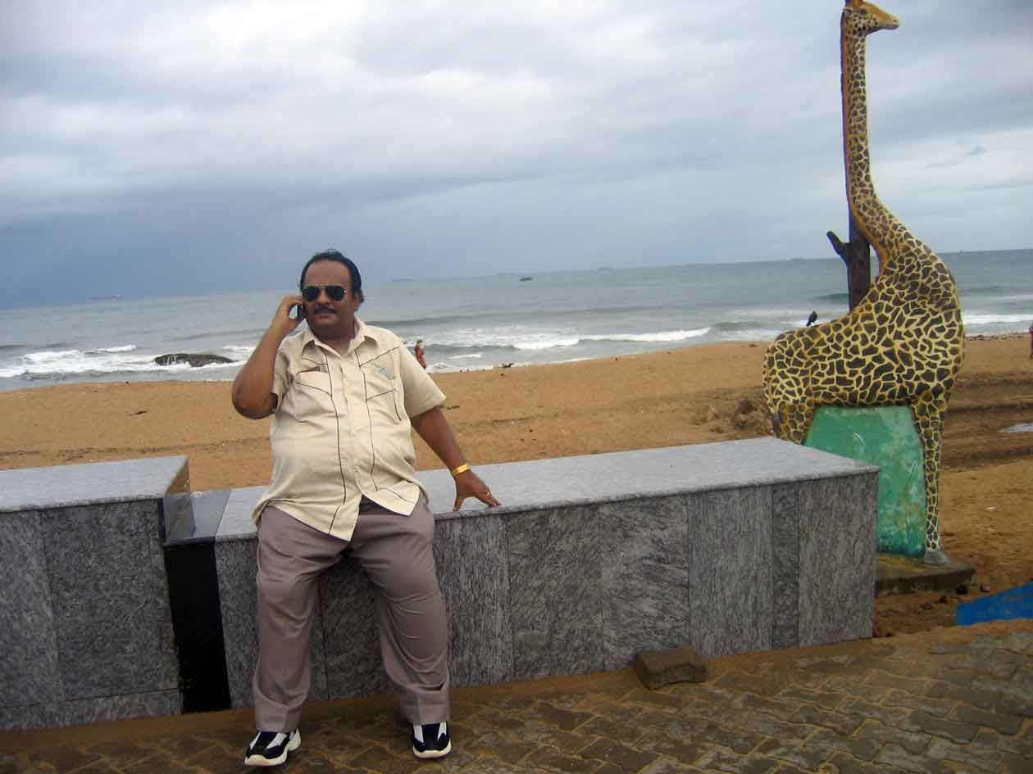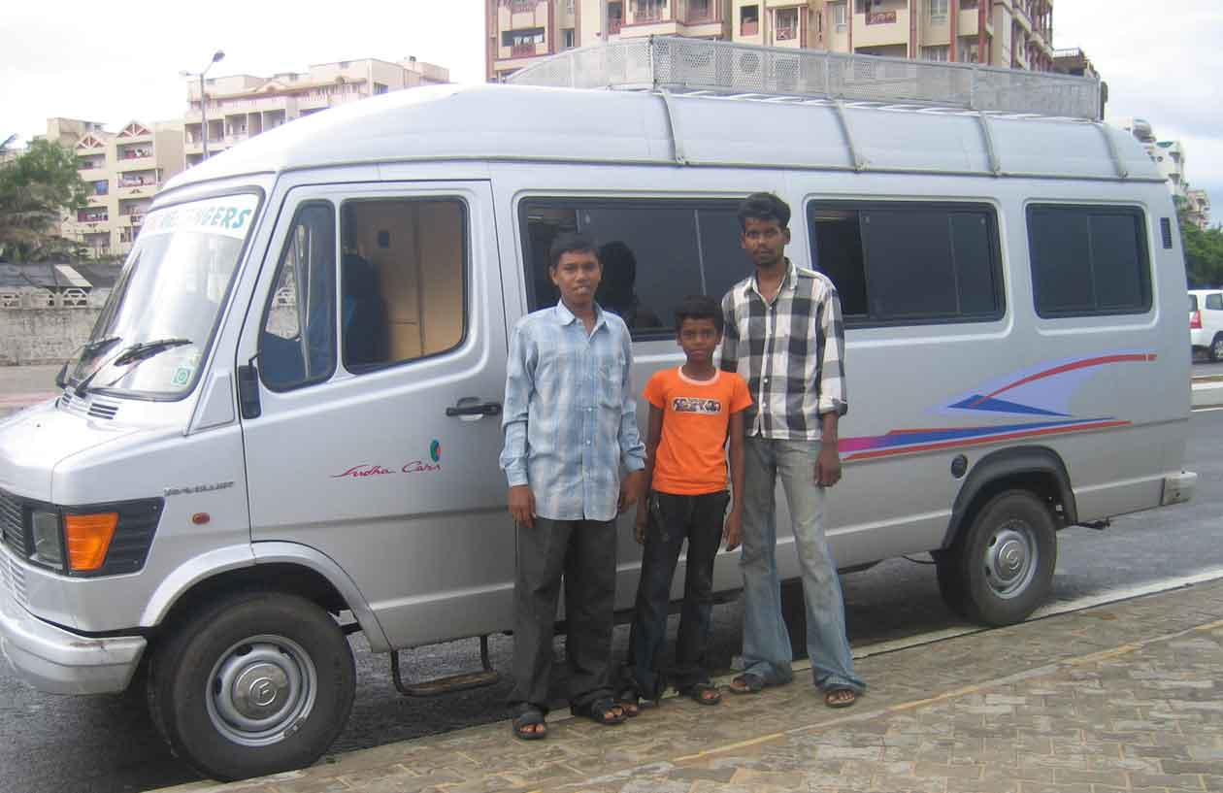
Even during the 1 hour recreation time at the near by sea Dr.Santhavardhan doing personal evangelism & counseling
Even during the recreation time Dr.Santhavardhan answering the prayer requests on the phone

Gospel van & Crew

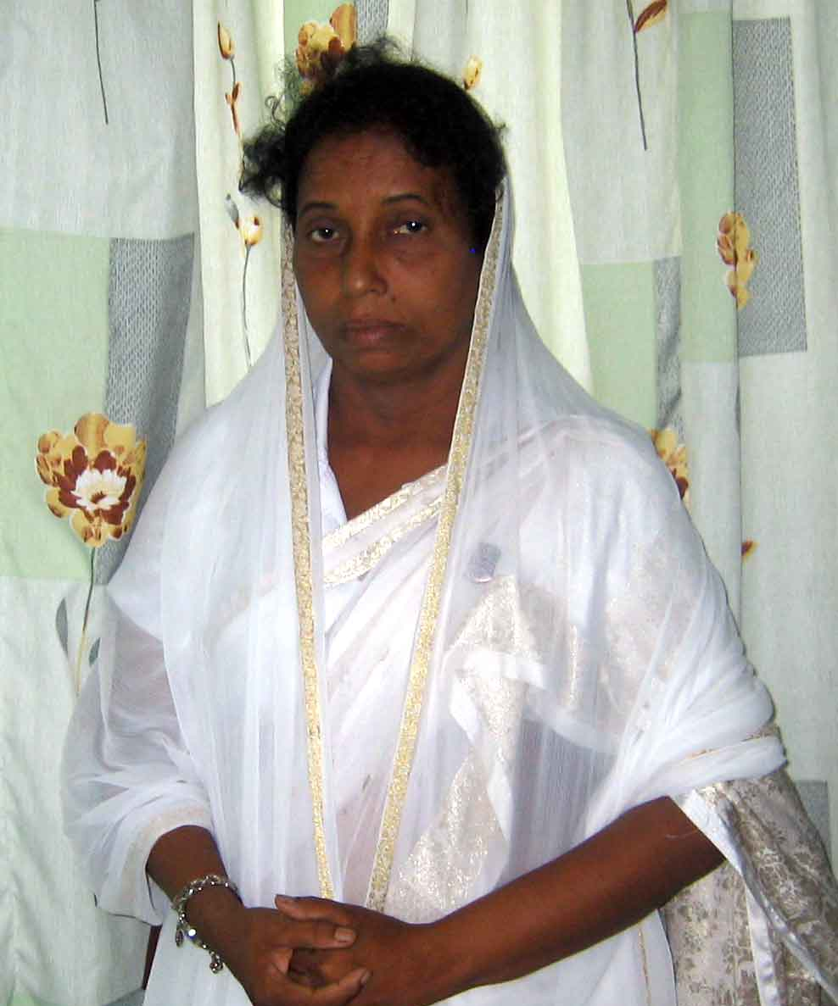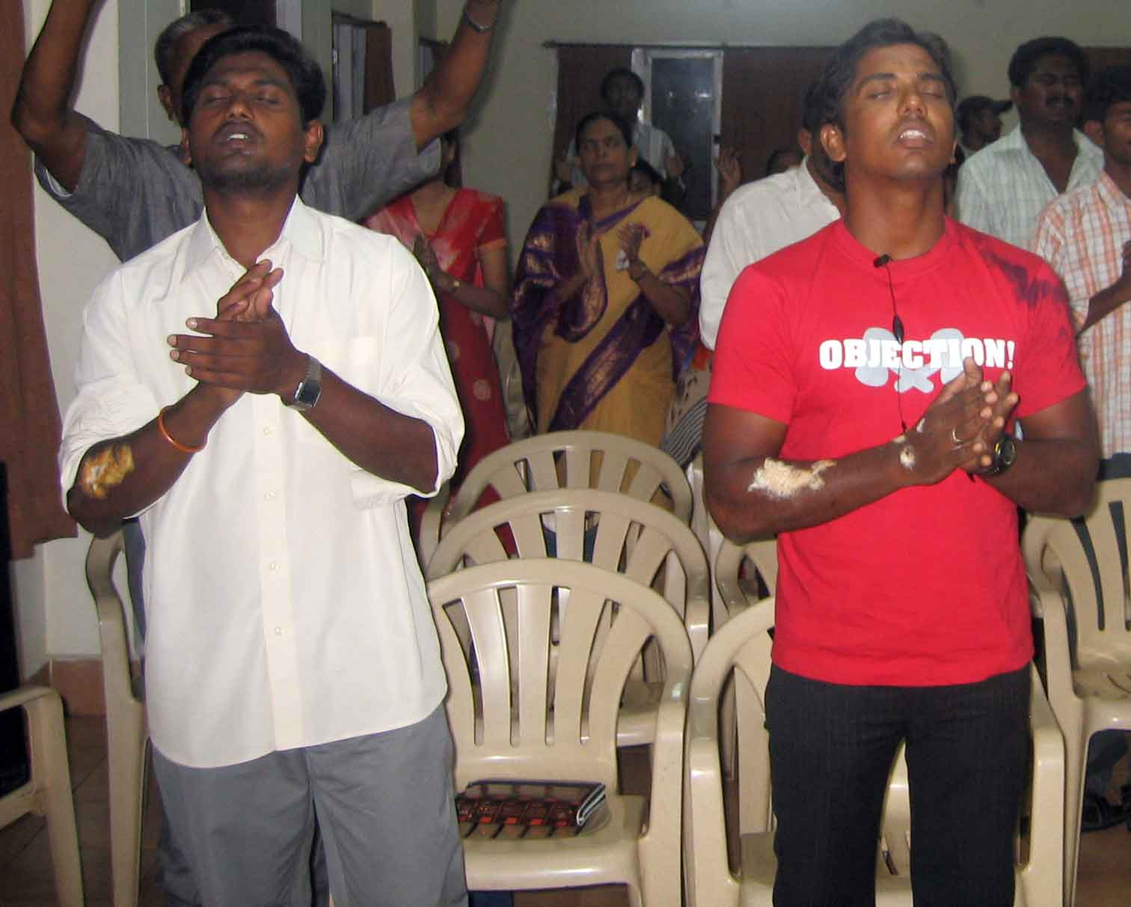
A sinner turned into a Evangelist
Note:her testimony would be sent in the next report
These two youngsters injured in a road accident on the same day morning ventured to attend this meeting held in the evening from their hospital bed
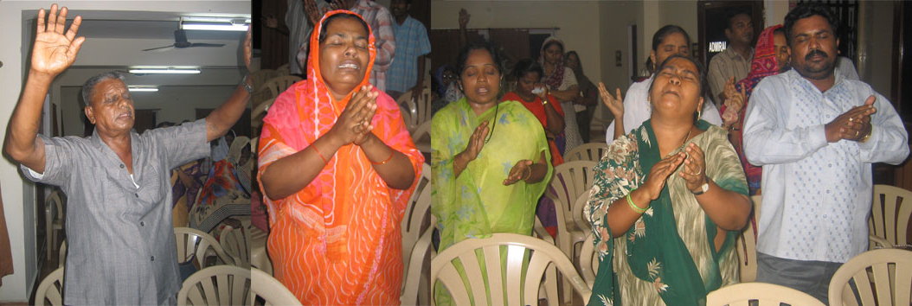
EFFECT OF PREACHING
Repentance and tear filled prayers

SECOND SATURDAY ALL NIGHT PRAYER AT
EL-SHADDAI CHURCH - GUNTUR

INSPITE OF THE HEAVY RAINS PEOPLE CAME FROM DIFFERENT VILLAGES AND TOWNS TO ATTEND THIS MEETING. THE CHURCH BUILDING WAS OVER-FLOWING WITH THE CROWDS.
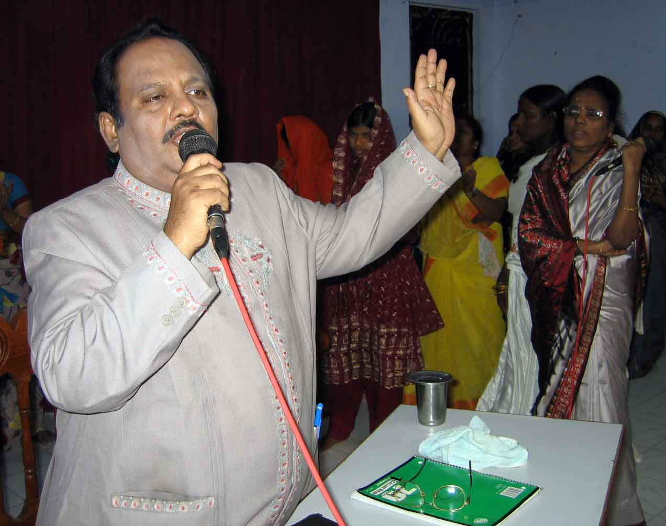
DR.SANTHAVARDHAN HAS PERSONALLY COUNSELED AND PRAYED FOR 200 PERSONS EACH INDIVIDUALLY APART FROM SINGING AND PREACHING ALL THROUGH THE NIGHT.

PEOPLE GAVE TREMENDOUS TESTIMONIES ABOUT THE WAY HOW THEY WERE BLESSED BY OUR T.V PROGRAMMES, TELEPHONE COUNSELING AND PRAYERS AND REGULAR WORSHIP SERVICES.

WE NEED LAND IN GUNTUR TO CONSTRUCT THE ORPHANAGE BUILDING, BIBLE SCHOOL AND A VERY BIG WORSHIP HOUSE. PLEASE PRAY.
Dr.Santhavardhan preaching

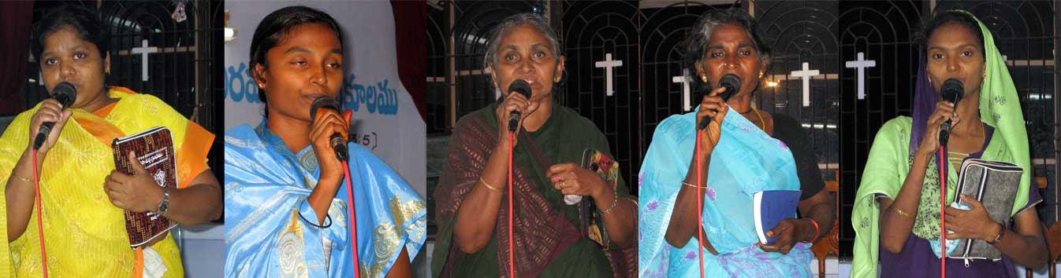
Several incredible & powerful testimonies wrought by Jesus in their lives through our ministry

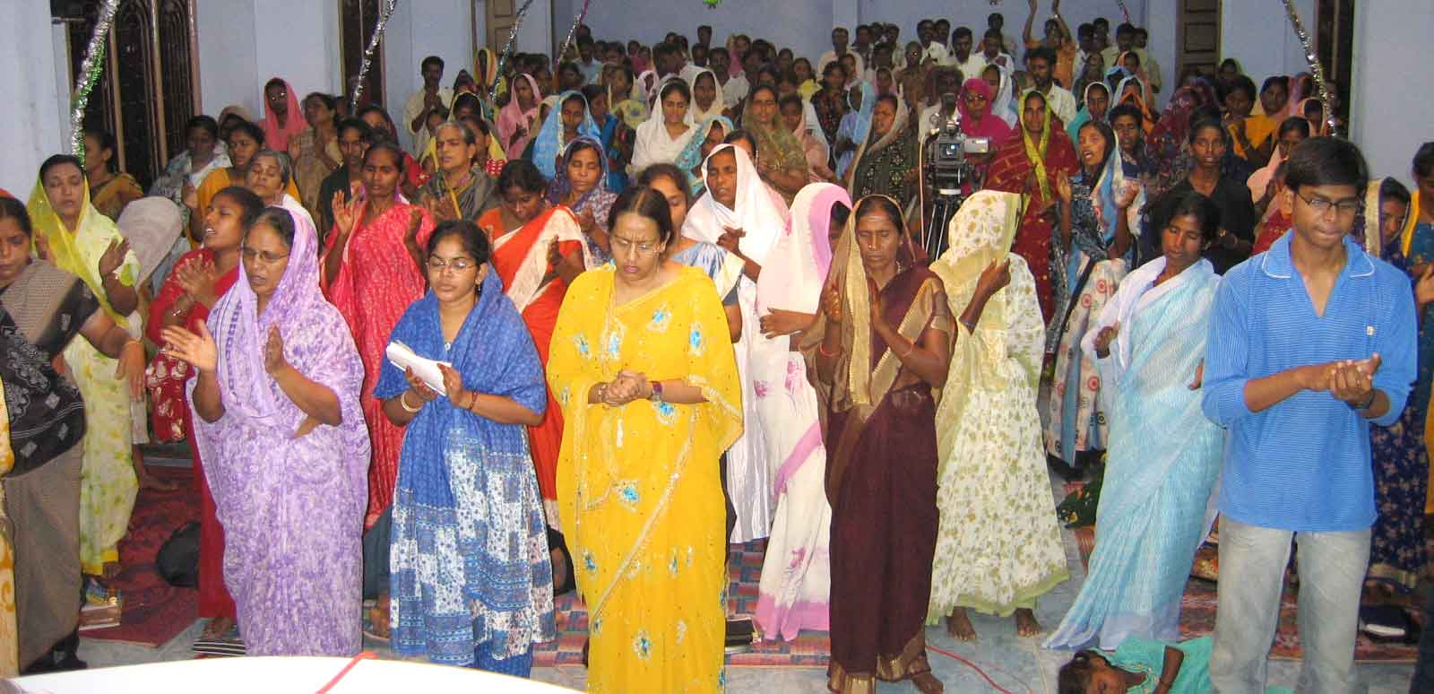
Crowded Church building

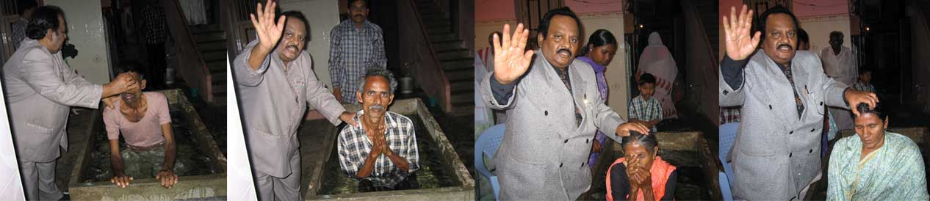
Impact of the ministry – Several baptisms every week

ALL EVENING MEETING AT VIJAYAWADA THE RIVER CITY

ON THE THIRD SATURDAY EVENING WE HELD ALL EVENING PRAYER AND PREACHING MEETING AT VIJAYAWADA WHERE DR.SANTHAVARDHAN HAS PREACHED AND MINISTERED ALONG WITH HIS MUSICIAN SON JAKIE. JAKIE WAS ANOINTED AS GOOD NEWS MESSENGERS PASTOR FOR VIJAYAWADA CITY. HE IS ALREADY STAYING IN THE CITY.
JAKIE IS PRODUCING A NEW GOSPEL MUSIC ALBUM IN HIS OWN STUDIO AND IT WOULD BE RELEASED NEXT MONTH.
OUR ‘NEW SONG BOOKS’ WERE RELEASED ON THIS OCCASION. 95% OF THE PEOPLE WHO ATTENDED THIS MEETING WERE HINDUS.
SEVERAL PEOPLE BLESSED BY OUR MINISTRY GAVE THEIR WONDERFUL TESTIMONIES IN THE MEETINGS GIVING GLORY TO THE LORD. ALL MARVELED AT THE POWER AND GRACE OF THE ONLY TRUE GOD LORD JESUS CHRIST. PRAISE THE LORD!

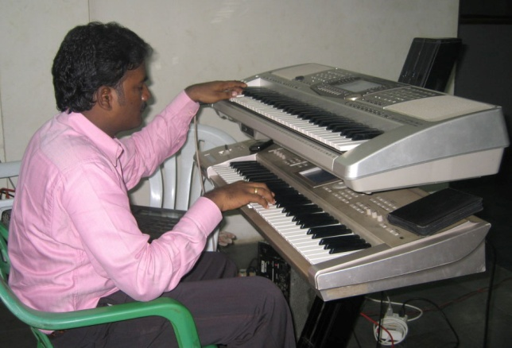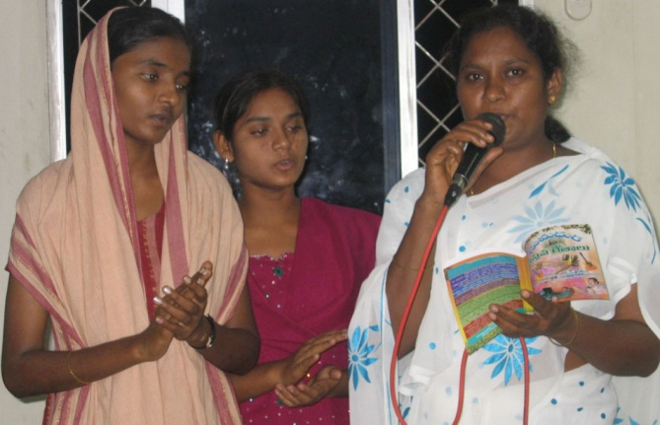
Music by Jakie with the singers

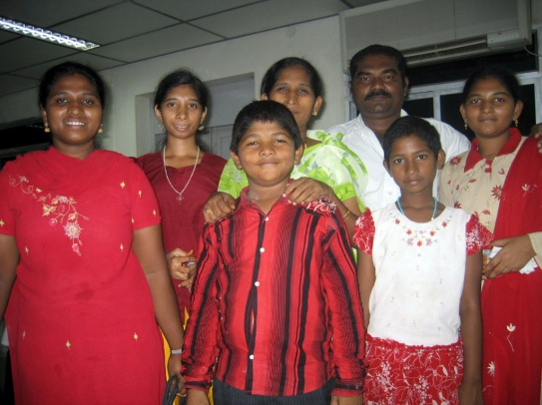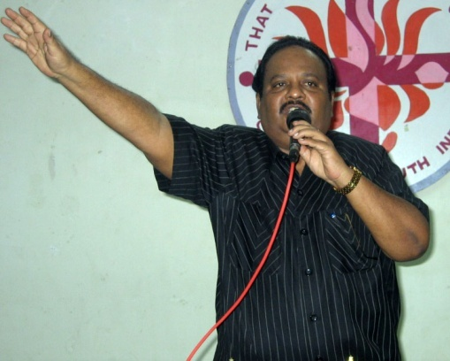
Entire family saved in the meeting

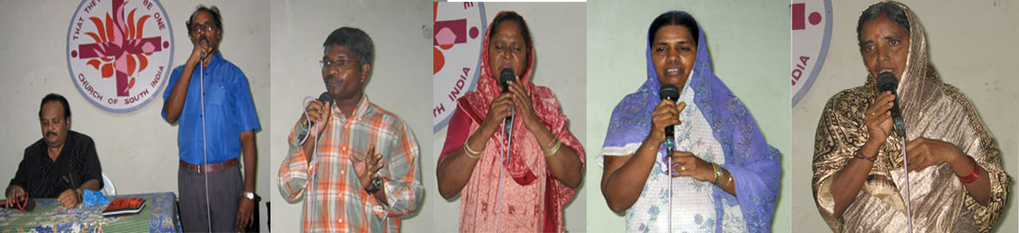
Several wonderful testimonies

YOUR HELP
YOU CAN SEND YOUR CHEQUES IN THE NAME OF ‘GOOD NEWS MESSENGERS’ AND MAIL THEM DIRECTLY TO THE FOLLOWING ADDRESS BY REGISTERED MAIL.
REV.DR.M.S.SANTHA VARDHAN
DIRECTOR,
GOOD NEWS MESSENGERS
‘EL-SHADDAI’ CHURCH
KANNAVARITHOTA 4TH LANE
GUNTUR-522004.
SOUTH INDIA
TELEPHONE: 011-91-863-2354536.
CELL PHONE: 9848113886.
YOU CAN DIRECTLY SEND THE MONEY BY MAIL TRANSFER TO OUR BANK ACCOUNT IN INDIA.
SWIFT CODE: SBI NIN BB 181
ACCOUNT NO: 10949477027
DONORS IN USA

to get the tax deductible receipts may send their cheques in the name of
CALVARY LIFE FELLOWSHIP.
(for Good News Messengers in India)
to the following address:
CALVARY LIFE FELLOWSHIP,
P.O.BOX: 1161, BREA,
California—92822,USA

For any other details about our ministry please contact
Merlyn in USA Tel:817-657-5689.
E-mail:dolly_mv@yahoo.com.
Thanking you very much.
Cordially yours in Christ,
Dr.M.S.Santha Vardhan.
Director:Good News Messengers.

www.goodnewsmessengers.org

