GOOD NEWS MESSENGERS
POST BOX- 306, KANNAVARITHOTA 4th LANE

GUNTUR (A.P) - INDIA – 522004
Email- Santhavardhan@yahoo.com www.goodnewsmessengers.org

Phone – 011-91-863-2354536

News Letter

Jan & Feb - 2007

Dr.M.S.Santhavardhan
DIRECTOR

Dear ones,

Greetings in Jesus Precious name.

I am very glad to inform you that we had tremendous ministry during the months of December 2006 & January 2007.

CHRISTMAS PROGRAMMES

In the name of Christmas celebrations we have given gospel in 8 cities and towns. I have given the gospel messages and my son JAKIE has conducted special musical concerts while the KIDS OF CHRIST (orphan children) in our ‘House of Hope’ orphanage gave dance performances and glorified GOD. People thronged for special prayers everywhere.

THE GIST OF MY CHRISTMAS MESSAGES MAY BE SUMMED UP IN THE FOLLOWING POINTS

WHY JESUS CAME TO THIS WORLD?
1) To fulfill the promise given un to David about the
continuation of his kingdom .That’s why Jesus is called the
son of David. His kingdom is eternal. So he came in the leniage
of king David to fulfill the promise given unto him
(Psalms 89:35).
2) To seek and save the lost (Luke 19:10).
3) To open the eyes of the blind (spiritually blind) (John 9:39).
4) To destroy the works of the devil (I John 3:8)
(Luke 13:10-13).
5) To save the sinners (I Timothy 1:15) (John 3:16).
6) Not to be ministered but to minister unto the mankind and
lay down his life for their salvation (Matthew 20:28)
(John 12:47).
7) To preach Gospel unto the poor --- (Luke 4:16-19).
To give sight unto the blind --- (II COR 4:4), to deliver the
captives (Luke 13:16) to heal the broken hearted
(Luke 7:49-50) and to announce the Acceptable year of the
lord.
8) To give us abundant life (John 10:10).
9) So that we may not live in darkness (John 12:46).
10) To send fire on earth (Luke 12:49-53).
2006-december ministry
The chair-person of the Andhra Pradesh state government women’s commission lauded our television programmes
Hyderabad meetings
The Andhra Pradesh government state women’s commission’s chair-person mrs.mary ravindranadh who was the chief-guest at our meetings at our state capital HYDERABAD highly lauded the services of good news messengers. she said that the gospel messagesgiven in their television programme are agreat blessing to many. people are spiritually educated and lead into salvation. she said she was also benefitted by the prayers and television programmes of the good news messengers.

Mrs.Usha Abraham, the chair-person of Baptist churches women’s conference who released good news messengers 2007 calendars highly spoke of the good news messengers ministries specially of their television programmes.

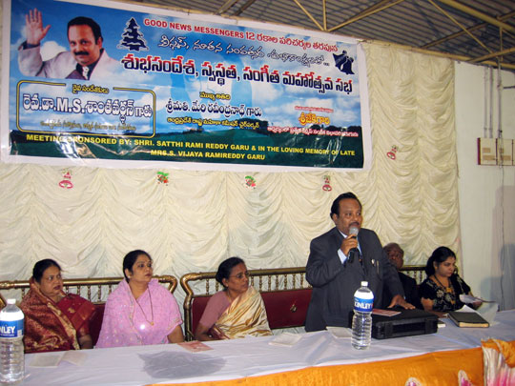
Dr.Santhavardhan &
VIPs on the Stage

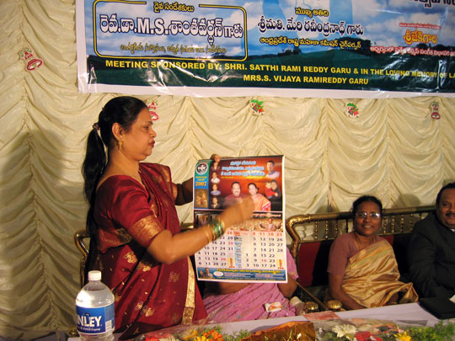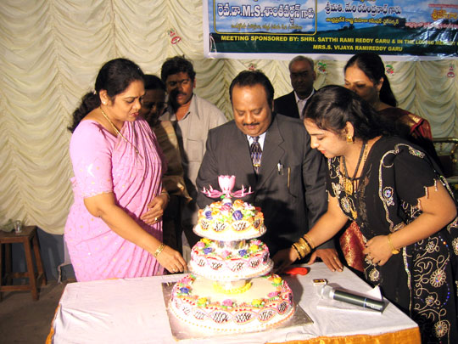
Baptist women’s leader Mrs.Usha Abraham releasing the Good News Messengers calendar
Chief-guest a.p women’s commission chair-person& another celebrity cutting the Christmas cake

2006-december ministry
The People waited until midnight to be blessed

at ATMAKUR, a little town in KURNOOL district the people were waiting for Dr.Santhavardhan and team to see him face to face and listen to the gospel. Even the little kids were waiting until midnight for this event. This town is very very close to the ‘NALLAMALA’ forest area where ‘NAXALITES’ (communist terrorist also known as ‘MAOISTS’ who belive that true freedom comes not through ‘DEMOCARCY’ but through the barrel of the GUN) are present.
Atmakur meetings

a popular physician dr.sunkanna and a highly placed government offical, asst.director Mr.Sathya Raju welcomed our team. they said that people in this backward area considered it as a great privilege and blessing to meet Dr.santhavardhan face to face and hear gospel.

All the spiritually hungry people (though they are very very poor people) were fed with our 3 hour gospel programme where there were messages, musical concerts, music and dance programme and special prayers. all glory to the lord.

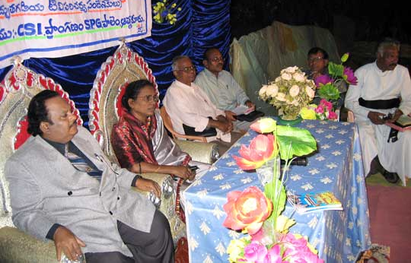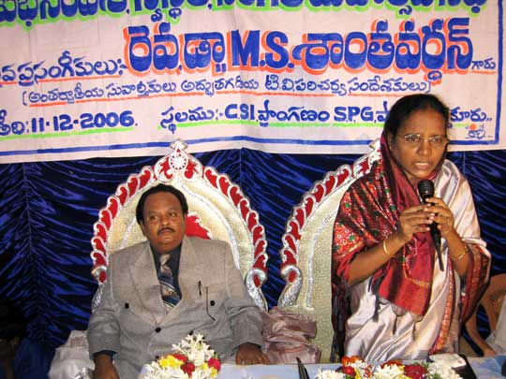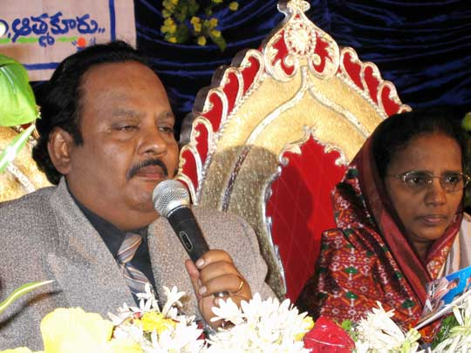
VIPs on the stage
Mrs.Nirmala Santhavardhan giving testimony
Dr.Santhavardhan Preaching

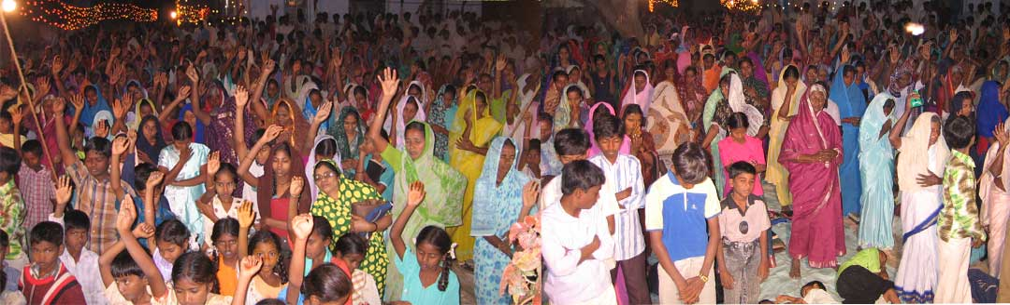
People that attended the meeting

2006-december ministry
Customs & central excise asst.commissioner praised the ministry and prayers of Good News Messengers and their services to the orphan children.
Vijayawada meetings
In the Vijayawada city ‘All Evening Meetings’ where Dr.Santhavardhan has preached and the orphan children gave music and dance performance and where the singers of the El-shaddai’ church (Guntur) gave musical concert under the leadership of Mr.Jakie, the music director.

The customs and central government official who was the chief guest wondered at the energies God has given to Dr.Santhvardhan to do such a tireless ministry throughout the state. His messages are always deep, inspiring and fruit-oriented. Thousands of souls are saved from every religion he said. several non-christians are saved because of the ‘gospel campaigns’ & ‘television ministry’ and their open testimonies given in the public meetings and television programmes are really amazing and shows the grace of the Lord and the power of the gospel in these ‘END TIMES’. His wife has highly appreciated the Good News Messengers for even taking care of the orphan children and nurturing them both physically and spiritually.

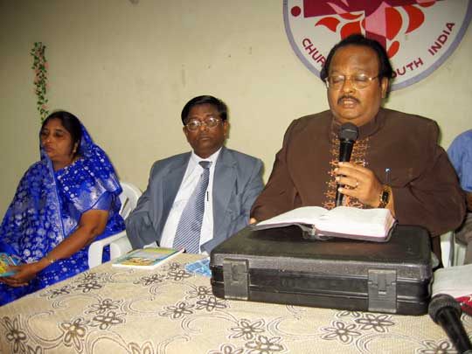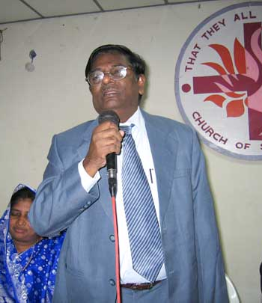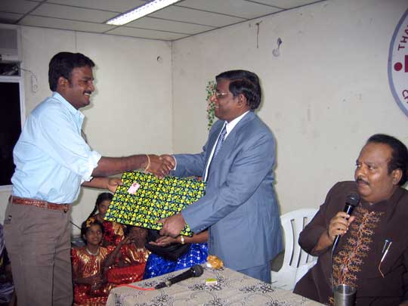
Dr.Santhavardhan
Preaching
Asst.commissionar of customs and central excise commending the service
Jakie presenting the momento on behalf of GoodNewsMessengers

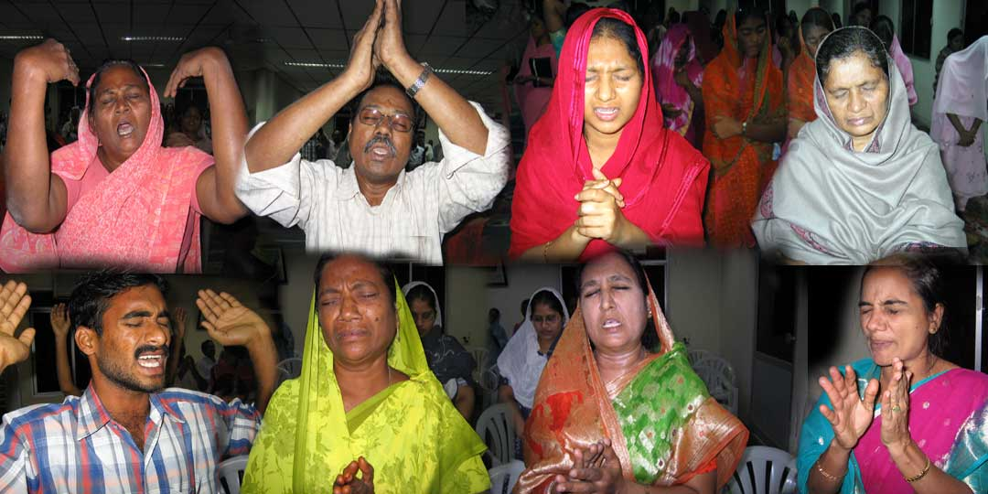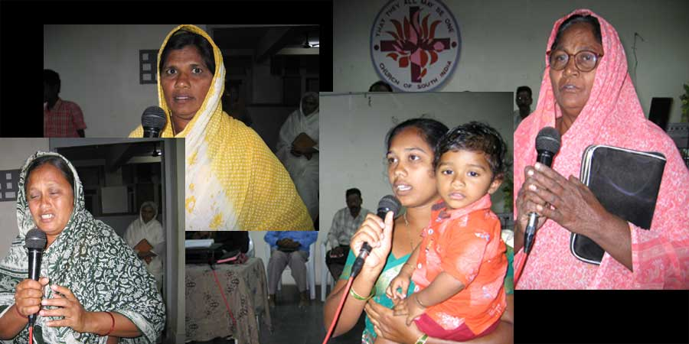
After Dr.Santhavardhan prayed the final prayer, Holy Spirit has moved upon the people in a mighty way
Several people testified how they were blessed by our ‘Adbhutha Gadiya’ television programme

2006-december ministry
The district collector and district magistrate of Anantapur district highly appreciated the gospel services of the Good News Messengers

Shri.Kadmiel Dasari IAS district collector and district magistrate of Anantapur district who participated in our meeting at Anantapur city openly appreciated the relentless ministry rendered by Dr.Santhavardhan through out the state. His wife gave testimony and said that the prayer of Dr.Santhavardhan has availed much in their lives and she was very much inspired and blessed by our television ministry.
anantapurmeetings

Hence she is now personally visiting several villages through out the district and encouraging the poor local evangelists apart from herself preaching the Gospel of Jesus Christ without any fear or hesitation inspite of their high official position. The district collector and his wife invited Dr.Santhavardhan’s team and gave good hospitality.
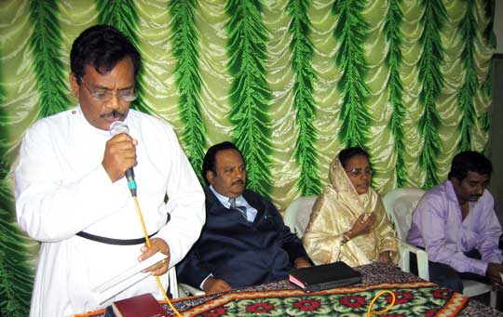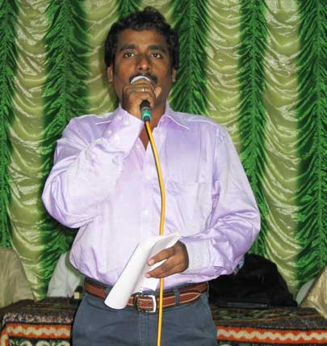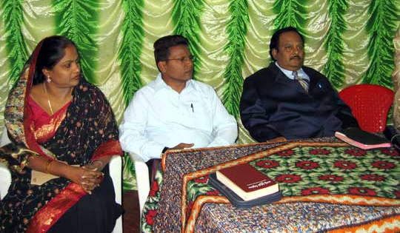
Opening prayer by
The Local pastor
Welcome by Shali
Co-ordinator
Good News Messengers
Speaker Dr.santhavardhan along with the District Collector & District magistrate & his wife

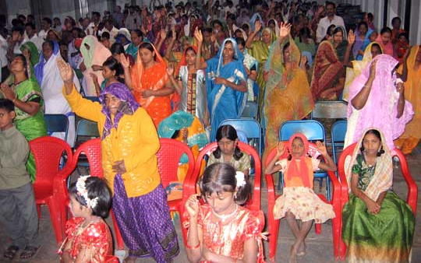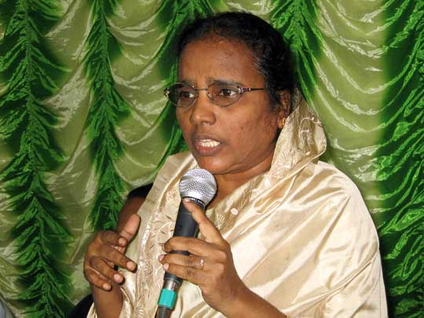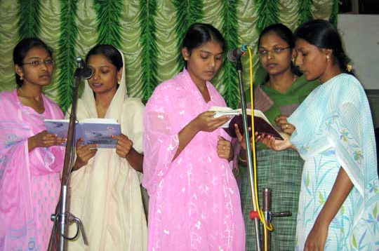
Mrs.Nirmala Santhavardhan giving testimony how Lord has saved her husband from death & healed
Those that responded to alter call
Local Choir

2006-december ministry
The entire village was fed by the villagers themselves on the eve of our meeting held at yedugundlapadu village

yedugundlapadumeetings
The entire village of ‘YEDUGUNDLAPADU’ (in Prakasam district of Andhra Pradesh) felt blessed (both Christians and non-christians) because of the one-day meeting held in their village where the well-renowned TV Evangelist came to their village and preached about Jesus Christ. They collected offerings and fed all the people in the entire village including the 20 persons in the Good News messengers team who went there in their special GOSPEL VAN. The music director and evangelist JAKIE was felicitated apart from Dr.Santhavardhan and he was given the title ‘SANGEETHA CHAKRAVARTHI’ (Emperor of Divine Music).

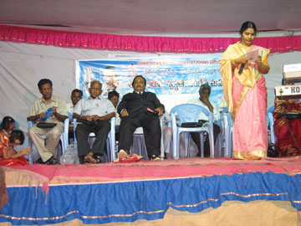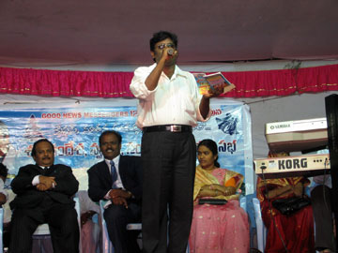
Singing & Worship

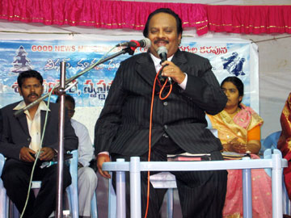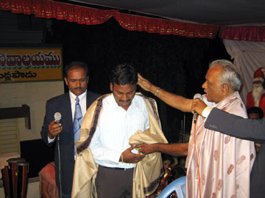
Dr.Santhavardhan
Preaching
Felicitation to
Jakie

All Night prayer and ministry on every month second Saturday night held in the ‘El-Shaddai’ church at Guntur

By God’s grace without breaking, since several years we are conducting All Night Prayers, Worship and ministry service on second Saturday of every month where new viewers of our television programmes mostly heathen attend, hear the gospel, get prayed and counseled. Several of them are baptized. People come out from various places of our state. Sometime ago a military man attended the prayers from Kashmir. In this meeting people give testimonies how they are blessed by our ministry. on every month third saturday evening, ‘all evening’ meeting is conducted in vijayawada city. Praise be to GOD.

United Pastor’s Christmas

Dr.Santhavardhan has given the Christmas message in the united pastor’s Christmas at Chilakaluripet town. We have also conducted such programmes in 6 of our rural and urban El-Shaddai churches.

Christmas celebrations in several places

Dr.Santhavardhan has visited several of our ‘El-Shaddai’ rural and urban churches and preached. the orphan children (kids of christ who are in the ‘house of hope’ orphanage) in a wounderful way displayed the christmas skits,performed ‘dance programmes’ while the musicians have counducted ‘musical concerts’ under the leadership of the music director jakie.
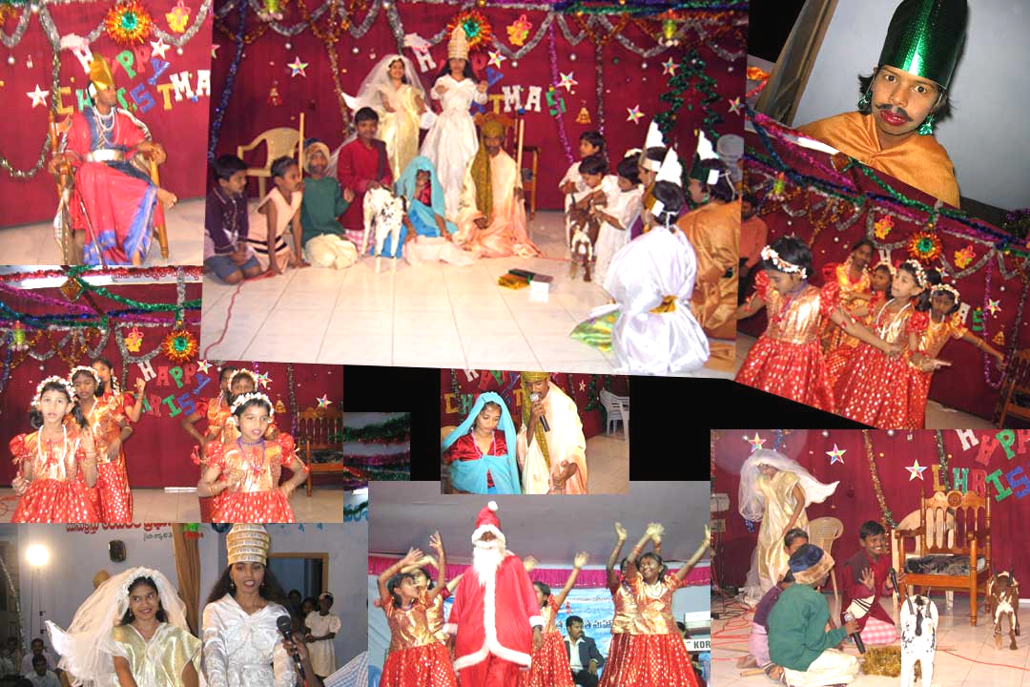
gifts & presentation of new clothes to 200 poor families

by gods grace we could present new cloths to 200 very poor christian families in our el-shaddai churches. our pastors and their wives were also given new cloths. praise be to god.

several competitions were held for the children like singing, preaching, bible quiz, RUNNING race etc., and they were given gifts on the occation.

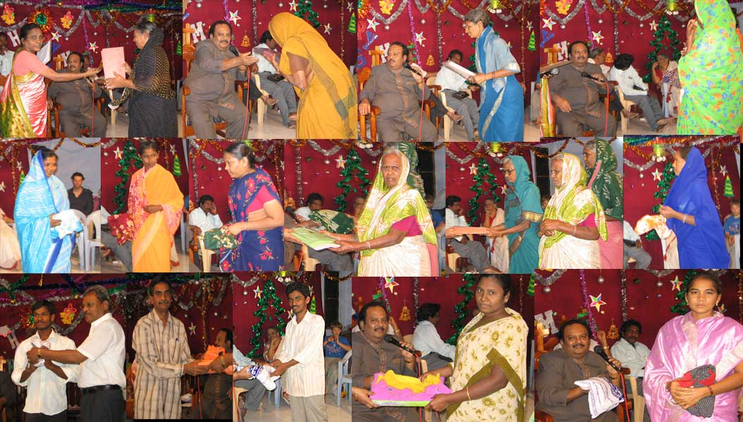

Dedication of the ‘bethesda’ baptist church &
gospel meetings at tadikonda village
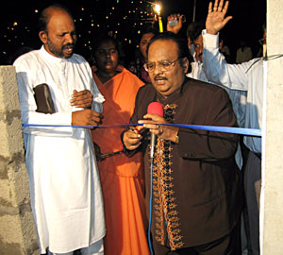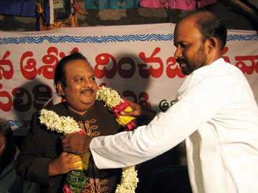

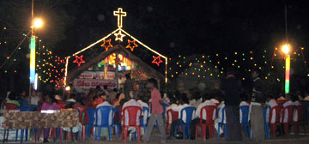
2006-december ministry
united community christmas at ponnur town

all most all the communities, hindus, musilms, christians and others even both protestants and catholics have organised ‘united city community’ christmas under the leadership of sri venkata rao at ponnur where all most all the town government officials, police officals and other political leaders of various parties and other vips have participated in the same.

the zilla parishad chair preson, mrs.vijaya, town mayor, state libraries chairman, loins club international president and others were the chief guests.

rev.dr.santhavardhan was invited to deliver the christmas message. it’s a rare honor and opportunity to preach gospel t the cross section of the society. several leaders acknoledged the great impact of his television messages on the society irrespective of caste, community or class differences.

all the Participents were given dinner. many sought personal prayers from dr.santhavardhan after the meetings.
praise be to god.

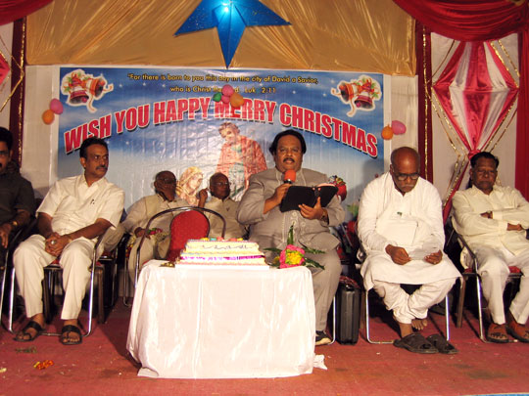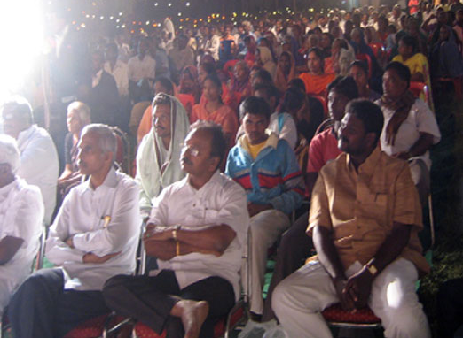

Watch night SERVICE NEW Year programme
Guntur City Mayor’s visit to EL-SHADDAI Church
(1st january 2007)

The Guntur city Mayor Mr.K.Nagaraju suddenly and surprisingly, though he is not a Christian, he came to the EL-SHADDAI church at Guntur. He sought the blessings of Dr.Santhavardhan and Christian community for God’s wisdom unto him in the New Year 2007 in regard to the city administration.

After the ‘Cake Cutting’ and ministry in the watch night service Dr.Santhavardhan and the entire EL-SHADDAI church extended prayers to the Mayor.

On the New years day morning Dr.Santhavardhan gave ‘New year’s message’ both in the ‘EL-SHADDAI’ church and also in the local main Baptist church, Guntur.

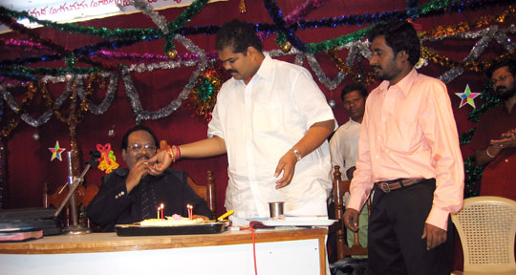
city Mayor Mr.K.Nagaraju

Graham Stains Memorial Award given to Dr.M.S.Santhavardhan

Graham stains was an Australian missionary serving along with his entire family ESPECIALLY in the state of Orissa India among the leapers .But Hindu fanatic group like Bajarangadhal and others were accusing him of religious conversions. A few years ago on a fateful night when the missionary along with his two little sons was sleeping in a jeep in the forest area Hindu fanatics under the leadership of Mr.Dara Sing attacked them and burnt them alive in the jeep. The Australian missionary Mr.Graham Stains along with his two sons, Phillip and Timothy were burnt alive when they were sleeping in their jeep on 22nd January 1999 in Mayurban’s district, village Manohara of Orissa state.

Subsequently the court in India has given death penalty to the culprit Dara Sing. However the punishment is not yet implemented as still the Hindu fanatic groups are praising his act and making him a ‘Hero’ and ‘Saviour’ of the Hindu community in India.

However Mrs.Gladys stains the wife of the slain Australian missionary Mr.Graham Stains who became a martyr on the Indian soil has forgiven the murderers of her husband and her two little innocent kids. She is continuing the ministry along with her little daughter left. The hundreds and thousands of the very poor leapers benefited by his services are still lamenting over his death.

Graham Stains Memorial Awards
(10th january 2007)

It is heartening to note that the ‘Sonic Vision’ (a multi media communication organization) on their 5th anniversary have instituted ‘Graham Stains’ memorial awards for a very very few persons who are doing exceptionally a very great ministry especially through their Christian television programmes reaching millions of people with the Gospel.

Dr.Santhavardhan is one such who received that very precious award given in a very special function held at Hyderabad on 10th January 2007. Several government state level high officials, ministers participated in the function. The Andhra Pradesh state chief minister’s wife Mrs.Vijaya Lakshmi Rajasekhar Reddy offered prayer. While chief ministers son-in-law, Mr.Anil a famous evangelist personally commended Rev.Dr.Santhavardhan, the award winner and others. The speaker of the A.P state legislative assembly, honorable Sri.Suresh Reddy gave away the awards. While the very famous Telugu movie actress and celebrity who accepted Lord Jesus Christ recently Mrs.Jaya Sudha and other dignitaries have given greetings.

Dr.Santhavardhan praised God and thanked the award givers, ministers and others for their greetings and thanked the Sonic Vision people for selecting him for such a rare and precious award.

He said God willing, ‘Adhbutha Ghadiya’ Television programmes which are a great blessing to millions of people would continue even in the years to come, He prayed God to bless the donors of our television programme through Dr.Lifsey.

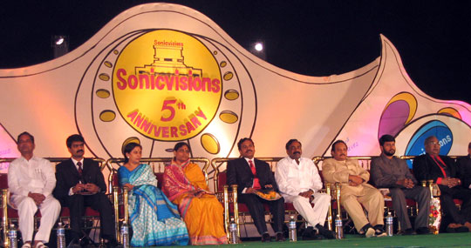
vips on the stage

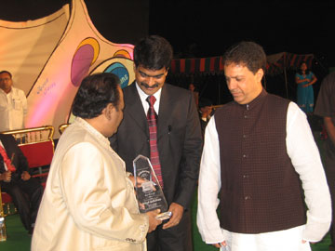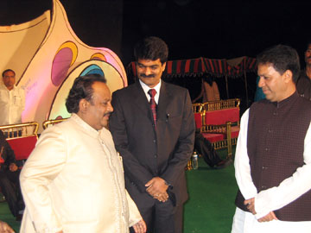
dR.sANTHAVARDHAN RECIVING THE AWARD FROM THE SPEAKER OF THE LEGISLATIVE ASSEMBLY

cHIEF MINISTER’S SON-IN-LAW mr.anil kumar COMMENDING DR.SANTHAVARDHAN

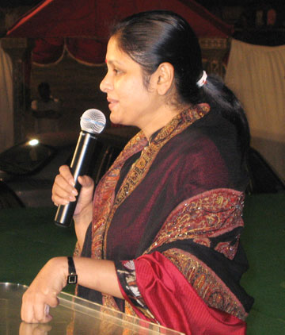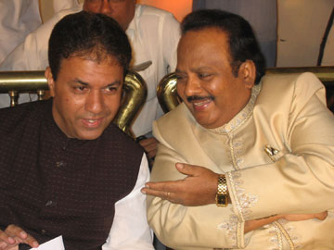
moviecelebrity
jaya shudha

dR.sANTHAVARDHAN with THE SPEAKER OF THE LEGISLATIVE ASSEMBLY

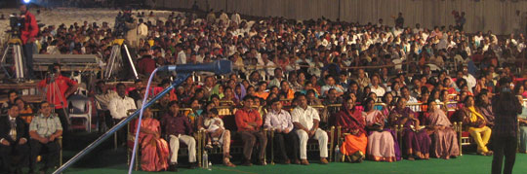
gathering at the function

AWARD FOR THE BEST SONG
(16th january 2007)

‘The voice of the world ministers’ have given ‘JESUS CHRIST ’award for the selected songs released in 2005. On this occasion Dr. Santha Vardhan and preachers from South Africa gave the messages .The song written, composed, sung and released by Dr. Santhavardhan (Maruchunna Eelokamlo) was adjudged as the best song of all the hundreds of gospel songs released by various people in that year. Mr.Jakie second son of Dr.Santhavardhan and the music director OF EL-Shaddai church rendered music to the song.
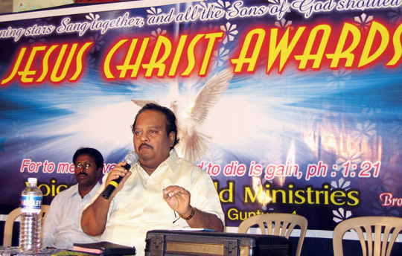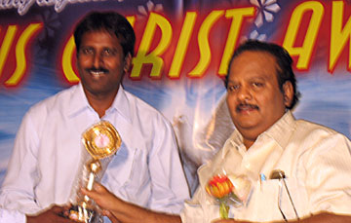

GOSPEL COMPAIGN AT PITAPURAM
(15th january 2007)

We have conducted a Gospel campaign in the Bathsheba Baptist church in the town of PITAPURAM of east Godavari district. The Church building was packed to its capacity people came even from the surrounding villages. Even the local Pastors were surprised to see such a gathering for this one day special meeting. It is amply proved that even the villagers in the remote places of our state are watching our television programmes weekly and being benefited.

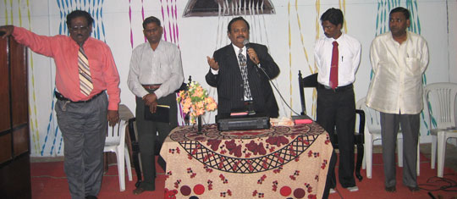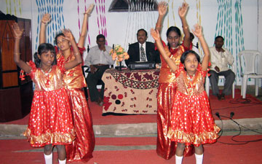

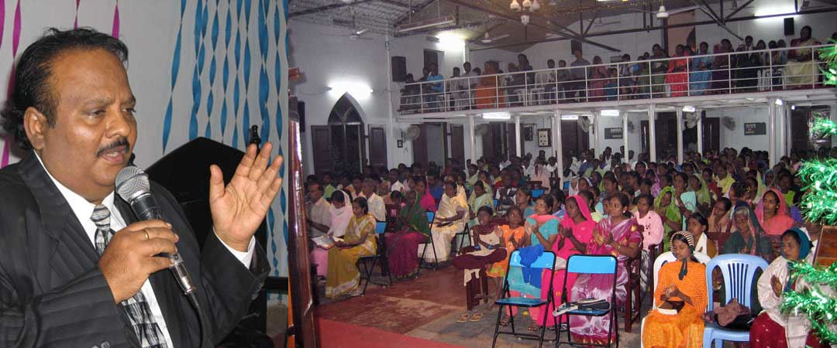

3 day Gospel campaign at KANIGIRI
(26th,27th & 28th January 2007)

We have conducted a 3 day Gospel campaign in the town of Kanigiri of Prakasham district. The Andhra Baptist mission grounds where the meetings were conducted was packed with crowds coming even from adjacent villages. Lord has used Dr.Santhavardhan in a mighty way. Lord has done miracles and many souls were saved in these meetings. On Sunday morning Dr.Santhavardhan has delivered one-and-half hrs message in the Sunday service held at Durgam Baptist Church, Kanigiri. Many testified that it has brought great revival in the church which was the need of the hour.

When Dr.Santhavardhan has preached under the unction of the Holy Ghost and prayed, thousands of people were moved praying aloud, crying and confessing their sins and accepting Lord Jesus Christ as their personal saviour. It was quite a wonderful scene to witness.

Mr.Jacob Jayanth vardhan, the music evangelist of Good News Messengers was very much appreciated for his talent and providing divine music to the local choir and special singers. People say he has the spirit of worship which was upon KING DAVID.

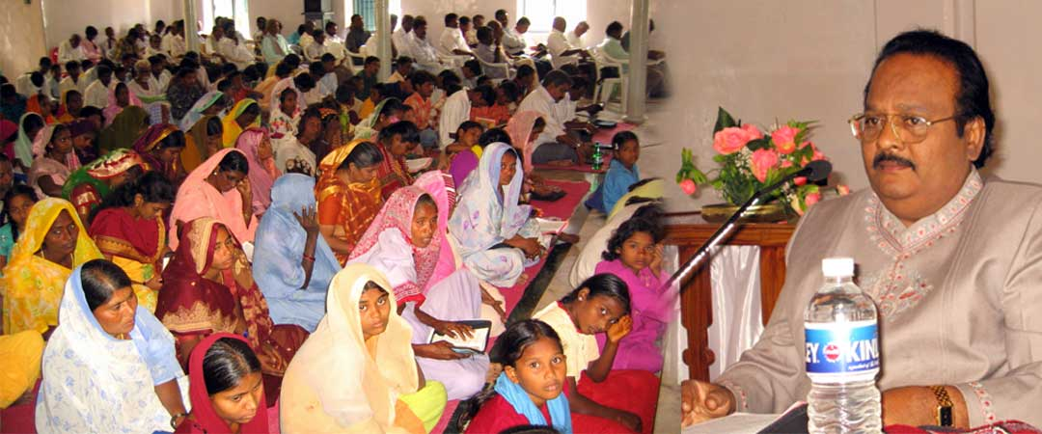
preaching in the local baptist church

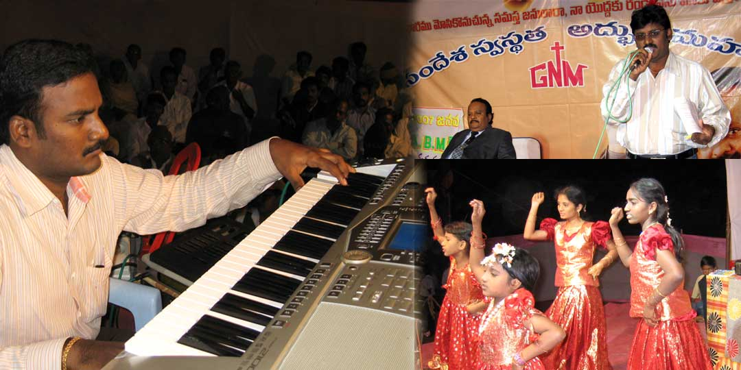
singing & dancing in the evening public meetings

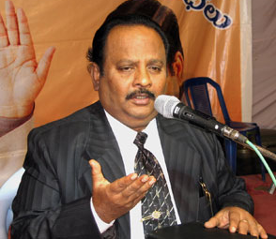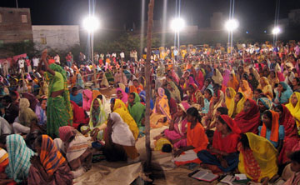
dr.santhavardhan
preaching

thousands of people
attended

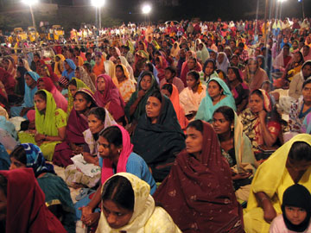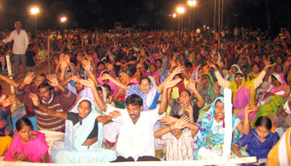
thousands accepted lord jesus christ

heard the word of god with rapt attention

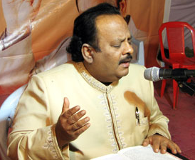
when dr.santhavardhan was singing & worshiping under the anointing, people were weeping,praying and confessing their sins and accepting lord jesus christ

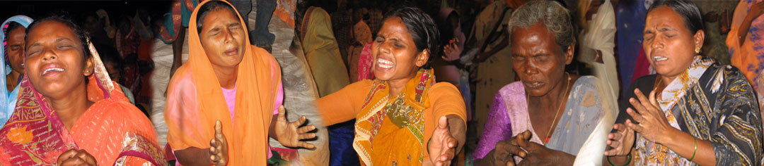
a serpent KILLED THEIR TWO SONS
JESUS SAVED THEIR FAMILY
18th january 2007)
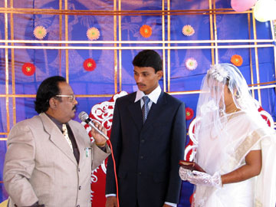
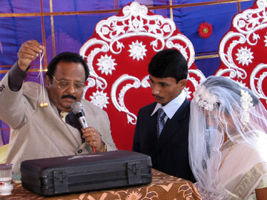
Sudhakar is a bank employee and a very staunch Hindu idol – worshipper. More than Sudhakar his wife Sujatha regularly worshiped several so called Hindu gods and goddesses every day. She was even an active member of the ‘Bajan mandali’ (choir group) of a local Hindu temple .More over the entire family worshiped serpent –goddess known as ‘Naga devatha’. generally many in india feed milk and worship the snakes. But unfortunately one night a poisonous snake came into the house of Sudhakar from nowhere and bitten the two grown-up sons of Sudhakar. So the two precious boys instantaneously died because of the snake-bite. Thus Sudhakar and Sujatha were now left with only one female child known as Annapurna.

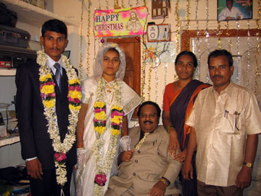
All of the remaining family members were in deep agony. Under these circumstances, Suddenly they have accidentally watched our ‘Adhbutha Ghadia’ television programme and were GREATLY COMFORTED by the messages given by Dr.Santhavardhan .They even attended the ‘ALL night PRAYERS’ and ‘Gospel campaign’ conducted by Dr. Santhavardhan in their own city Hanmakonda conducted by the Good News Messengers. He even preached once about how satan in the form of a seperant decived ‘EVE’ and how ‘SIN’ has affected the entire humanity because of the sin of dis-obedience ofAdam & Eve. He also explained how Jesus became man (sinless) and came to this world and laid down his life for the salvation of the entire humanity.only through having living faith in the resurrected Christ one can have salvation and go to heaven. This thought-provoking message has opened the eyes of the wife and daughter of Sudhakar. As a result all of them have accepted lord Jesus Christ and were baptized by Dr.Santhavardhan. Even the Hindu boy who was willing to marry their daughter went to Guntur, heard about Jesus Christ accepted the Lord and was baptized. Several heathen who heard the testimony of the family attended the wedding and heard the wedding message and got prayed by Dr.Santhavardhan.

Even the priest of the Hindhu temple where this family were worshiping previously attended the wedding, met Dr.Santhavardhan and marveled and said that that he is amazed at the radical change in that family and came to see the person who changed them to Christianity. But Dr.santhavardhan said that only Jesus has changed their lives radically and he is only an instrument in the hands of the Lord.

Praise be to God for our television programme has brought such a change in that orthodox Hindu family, saved them from the agony of losing their two precious sons who died in the snake-bite. All Glory to Jesus. Dr .Santhavardhan has conducted their wedding at Hanmakonda on 18th January 2007.

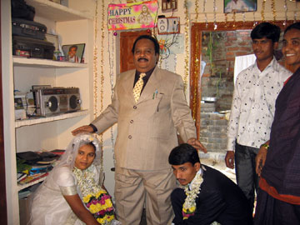

ALL EVENING MEETING

The same day evening Dr.santhavardhan preached in the public meeting arranged in the ‘All Saints High School’ grounds in the Hanmakonda city where Mr.Joseph, the Dy.Superinent of District prison has participated in the meetings as the chief-guest and highly commended the services of the Good News Messengers specially their television Programmes which is a great blessing to countless number of people including the people in prison and the orthodox people who never venture to come out of their homes to attend such gospel meetings publicly.

He praised God and extended his thanks to the organizers of such television programme where such powerful messages are given by the chosen servant of the Lord.

He even congratulated Dr.Santhavardhan for getting the ‘Graham Stains’ memorial Award by the speaker of the legislature for his excellent service SPECIALLY through the ‘Adbhutha Gadiya’ television programme. Praise be to God.

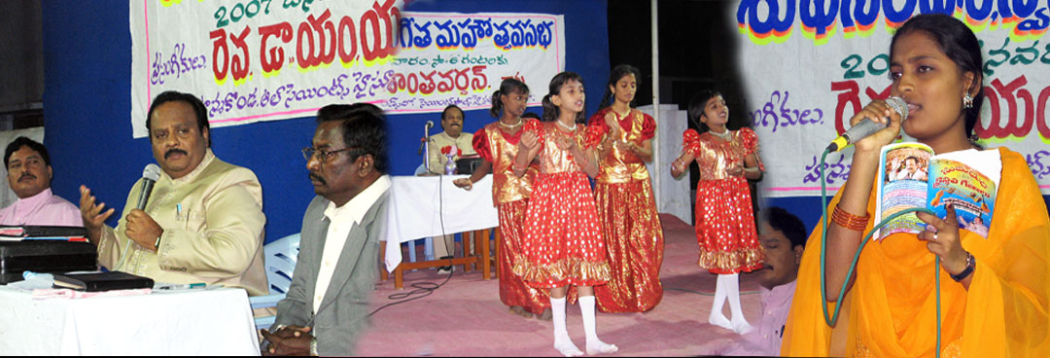

ONE WEEK FASTING PRAYERS

In the month of January we have also conducted 7 days fasting prayers in the EL-SHADDAI CHRUCH, GUNTUR for all our prayer partners in India and aboard. There was a great response for all these meetings.

ALL NIGHT PRAYER MEETINGS

All night prayer meeting was conducted in the ‘EL-SHADDAI ‘church, Guntur on 13th January night.

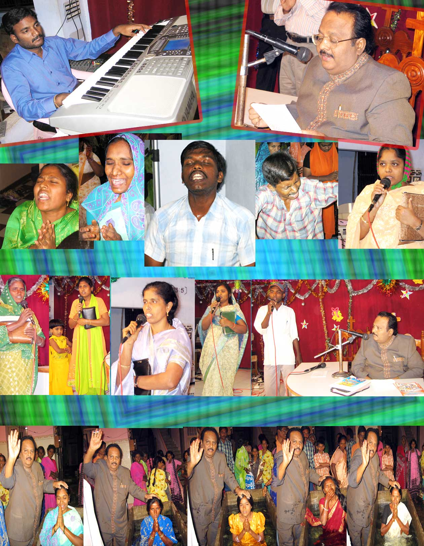
baptisims
testimonies

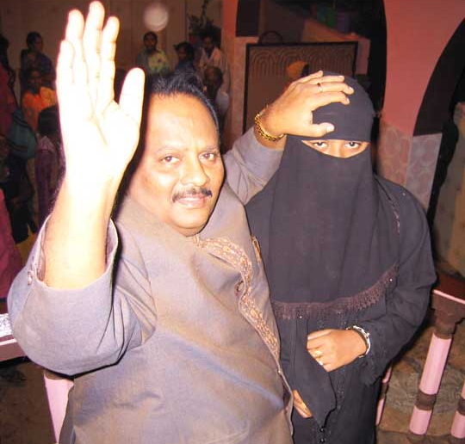
special prayers

35th wedding anniversary of
MRS & dr.santhavardhan
(7th february 2007)

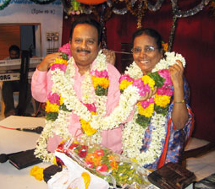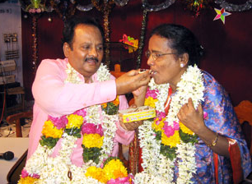

PROPOSED MEETINGS

god willing, Gospel meetings are going to be conducted at KADAPA town on 2nd, 3rd & 4th of March 2007.

APPEAL

We request our prayer partners specially NRIs to sponsor such meetings. Atleast a minimum of 7000 U.S. dollors are required to conduct a 3 days Gospel campaign on a medium scale.

KIDS OF CHRIST IN THE HOUSE OF HOPE

Please remember the kids of Christ (Orphan children) in our ‘House of Hope’ orphanages who are in urgent need of orphanage buildings for them. we are looking to the lord for land to construct orphanage buildings and specially a ‘Bible School’ to produce soul winners for the lord in these end times, for the earth and its fullness is of the lord’s.

Special prayers

we are going to have 40 nights special fasting prayers starting from 21st February 2007, specially to pray for all the good news messengers ministries and benifactors and donors. already 3 days special fasting prayers were counducted for the health ofsherly, wife of dr.lifsey.

YOUR HELP

YOU CAN SEND YOUR CHEQUES IN THE NAME OF ‘GOOD NEWS MESSENGERS’ AND MAIL THEM DIRECTLY TO THE FOLLOWING ADDRESS BY REGISTRED MAIL.

REV.DR.M.S.SANTHA VARDHAN
DIRECTOR,
GOOD NEWS MESSENGERS
‘EL-SHADDAI’ CHURCH
KANNAVARITHOTA 4TH LANE
GUNTUR-522004.
SOUTH INDIA

TELEPHONE: 011-91-863-2354536.
CELL PHONE: 9848113886.

YOU CAN DIRECTLY SEND THE MONEY BY MAIL TRANSFER TO OUR BANK ACCOUNT IN INDIA.

SWIFT CODE: SBI NIN BB 181
ACCOUNT NO: 011 0000 5254

DONORS IN USA
to get the tax deductible receipts may send their cheques in the name of
CALVARY LIFE FELLOWSHIP.
(for Good News Messengers in India)
to the following address:
CALVARY LIFE FELLOWSHIP,
P.O.BOX: 1161, BREA,
California—92822,USA

For any other details about our ministry please contact
Merlyn in USA Tel:817-657-5689.
E-mail:dolly_mv@yahoo.com.

Thanking you very much.
Cordially yours in Christ,
Dr.M.S.Santha Vardhan.
Director:Good News Messengers.

www.goodnewsmessengers.org

